https://harvard-iacs.github.io/2019-CS109A/

CAP5768/IDC4140:

Introduction to Data Science

Guang Wang Department of Computer Science

Florida State University

Model Selection

### Lecture Outline

**Overfitting** Model Selection 6543TGREPCHECK2&&**(11 Cross Validation Bias vs Variance

3

### What we need to select: Hyperparameters

**Hyperparameters control the**

**algorithm by determining what kind of model it will learn and how it will do the learning**



What hyper- parameters?

Hyperparameters: Settings that control the learning algorithm

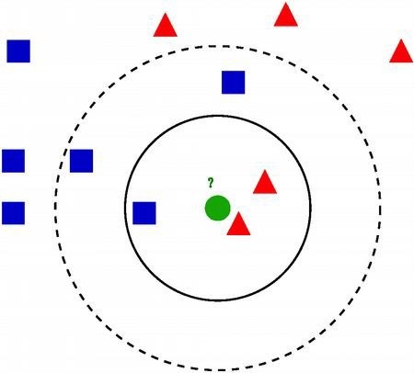**Nearest Neighbours**

**k**

**Input:** Category known for some documents but not for new one

1. **Determine nearest neighbours**

**k (e.g. 3)**

**of the new document**

1. **k-NN Voting:**

What is the majority label of those k nearest neighbors?

# Hyperparameters: Settings that control the learning algorithm

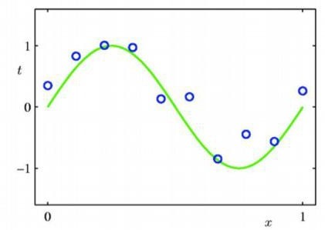Polynomial Curve Fitting

# Parameters: Learnt automatically

Polynomial Curve Fitting

### Parameters: Learned automatically

**Parameters: All of these belong to the vector of parameters θ the machine learning algorithm will optimize on its own**

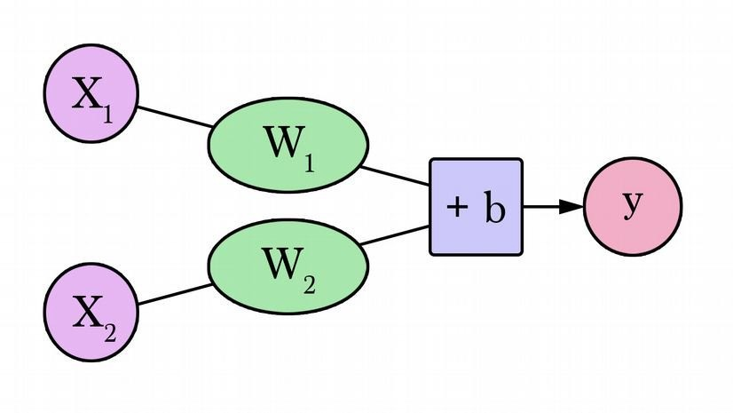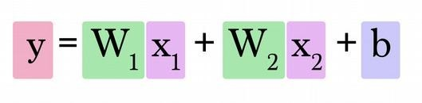

Source: J. Alammar. https://jalammar.github.io/visual-interactive-guide-basics-neural-networks/

What we need to select: Features and Output

What/how many features?

How are the feature values represented?

What kind of preprocessing and transformations?

How is the output represented? Etc.



What kinds of features and output?

What criteria can we use for selecting models?



Why not error on training set?



Too easy:

The algorithm gets trained on this data, and some algorithms simply memorize the training data.

## Also: Overfitting

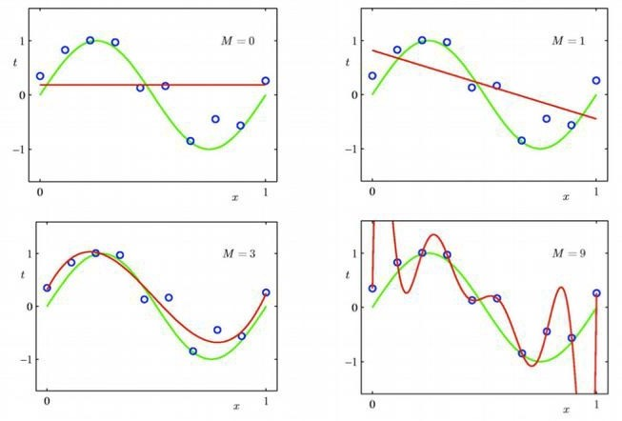

### Also: Overfitting

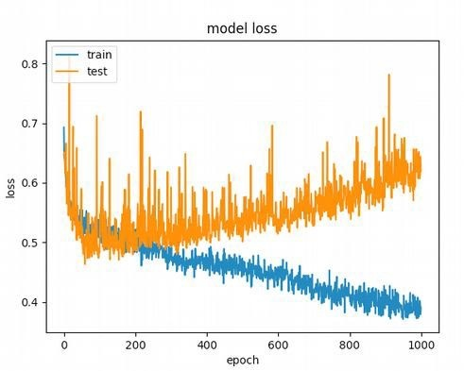

https://stackoverflow.com/questions/44909134/how-to-avoid-overfitting-on-a-simple-feed-forward-network/44985765

### Training vs. Test Sets

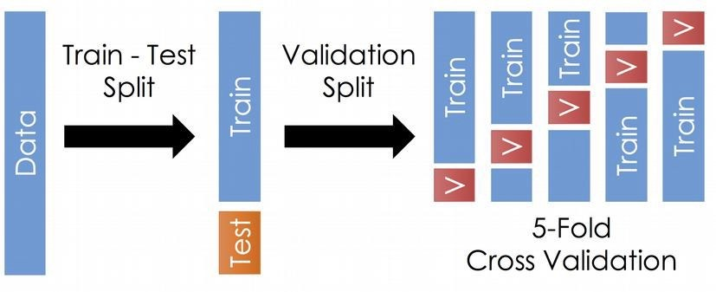

E.g.

70% for training,

30% for test

<http://www.ds100.org/sp17/assets/notebooks/linear_regression/Cross_Validation_and_the_Bias_Variance_Tradeoff.html>

### What criteria can we use for selecting models?



Why not error on test set?

The test set is supposed to serve as a sort of final examination

to see how well the model works

on data is hasn't seen before.

But if we get to keep re-taking the test with slightly different models, then the test will no longer be

an unbiased evaluation of how well our model will work on new data. There could be overfitting on the test data.

Option 1: Validation Set



Use validation set as

a surrogate test set while selecting and tuning models.

<http://www.ds100.org/sp17/assets/notebooks/linear_regression/Cross_Validation_and_the_Bias_Variance_Tradeoff.html>

## Option 1: Validation Set

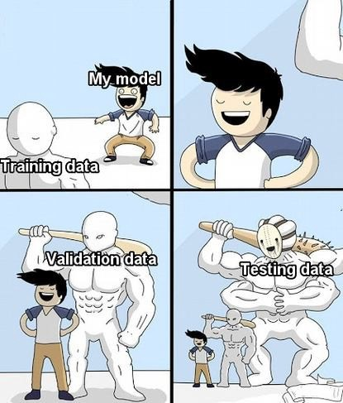

https://twitter.com/ai_memes/status/1117751647529328640

### Option 1: Validation Set



Using a validation set is often a good enough choice.



Improvement:

repeat process for k alternative splits and take average.



5-fold CV → 5 folds, each with 1/5 of data for validation, 4/5 for training

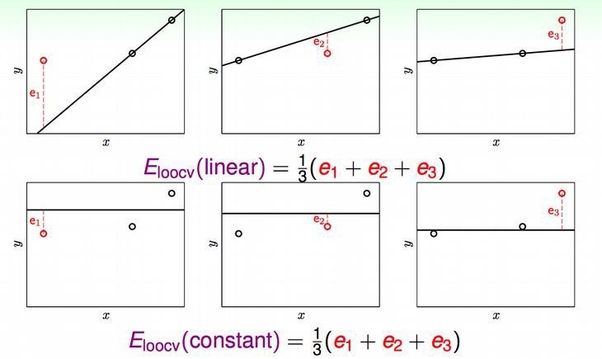

Try to predict 1 training example using only the remaining training examples

for training



Try to predict 1 training example using only the remaining training examples

for training



Try to predict 1 training example using only the remaining training examples

for training



Try to predict 1 training example using only the remaining training examples

for training

Downside: Learning a large number of models can be slow.

Model Selection

Conclusion: Depending on how long one training iteration takes, use one of the following:

* Fixed Validation Set
* K-Fold Cross-Validation
* Leave-One-Out Cross-Validation

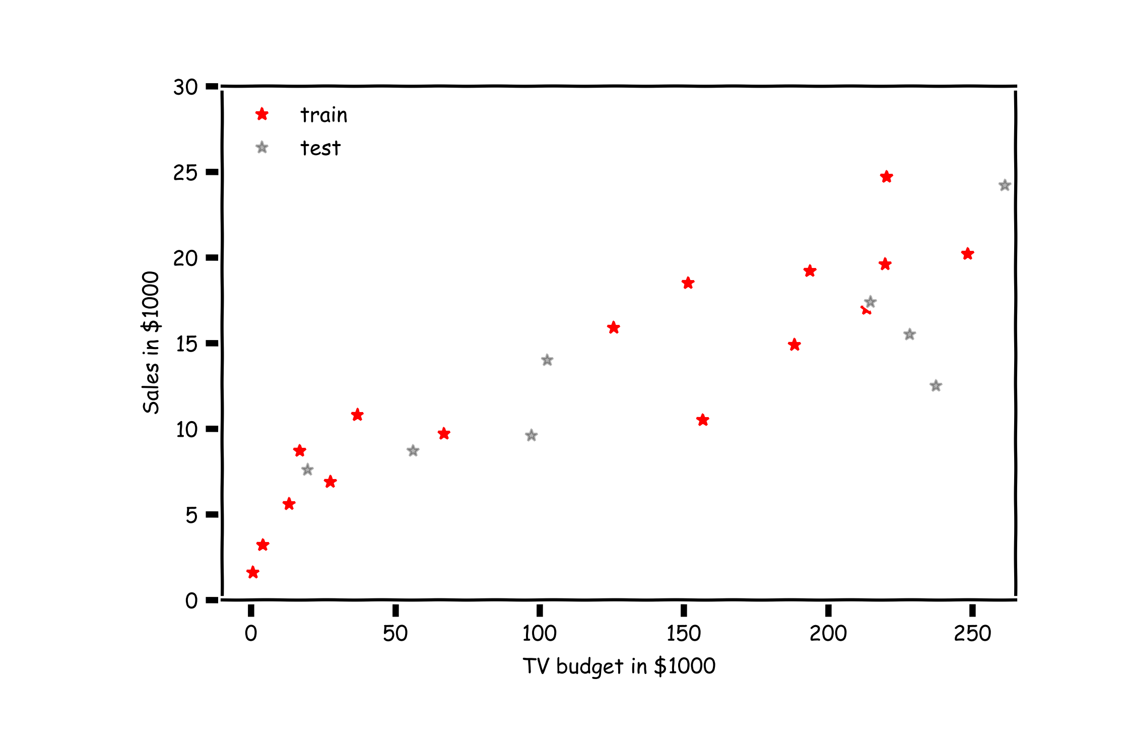

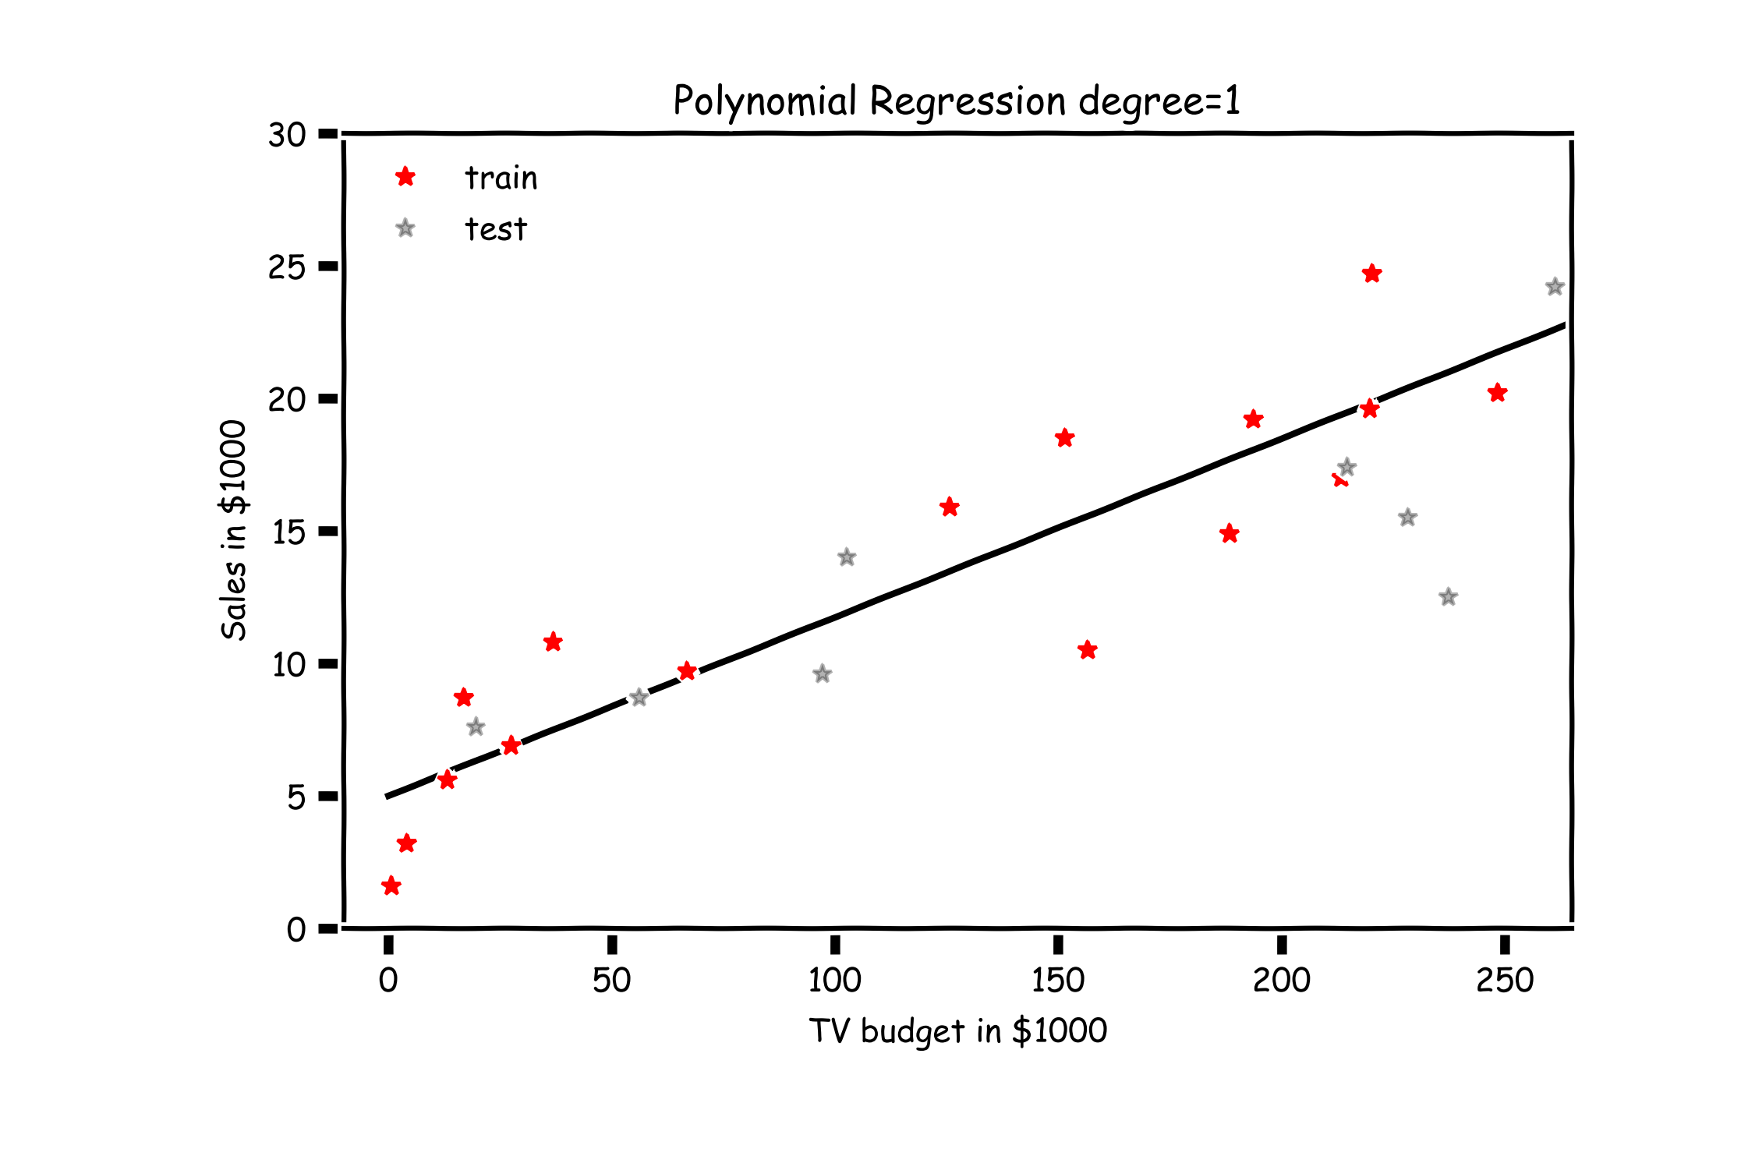

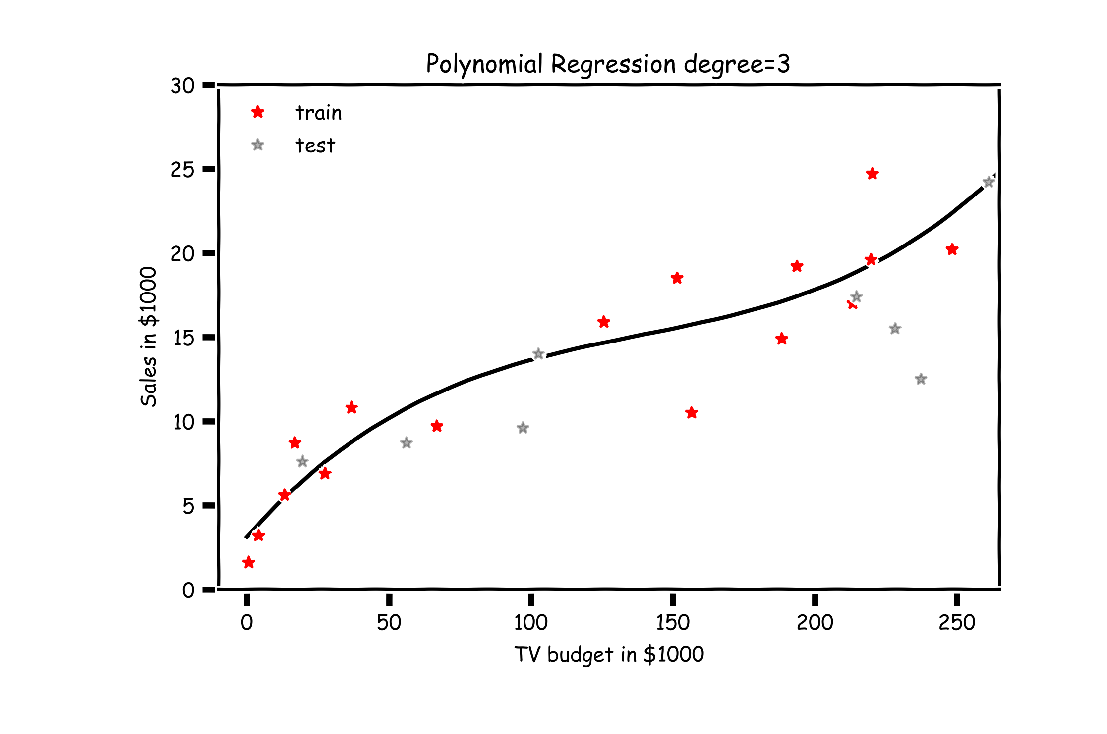

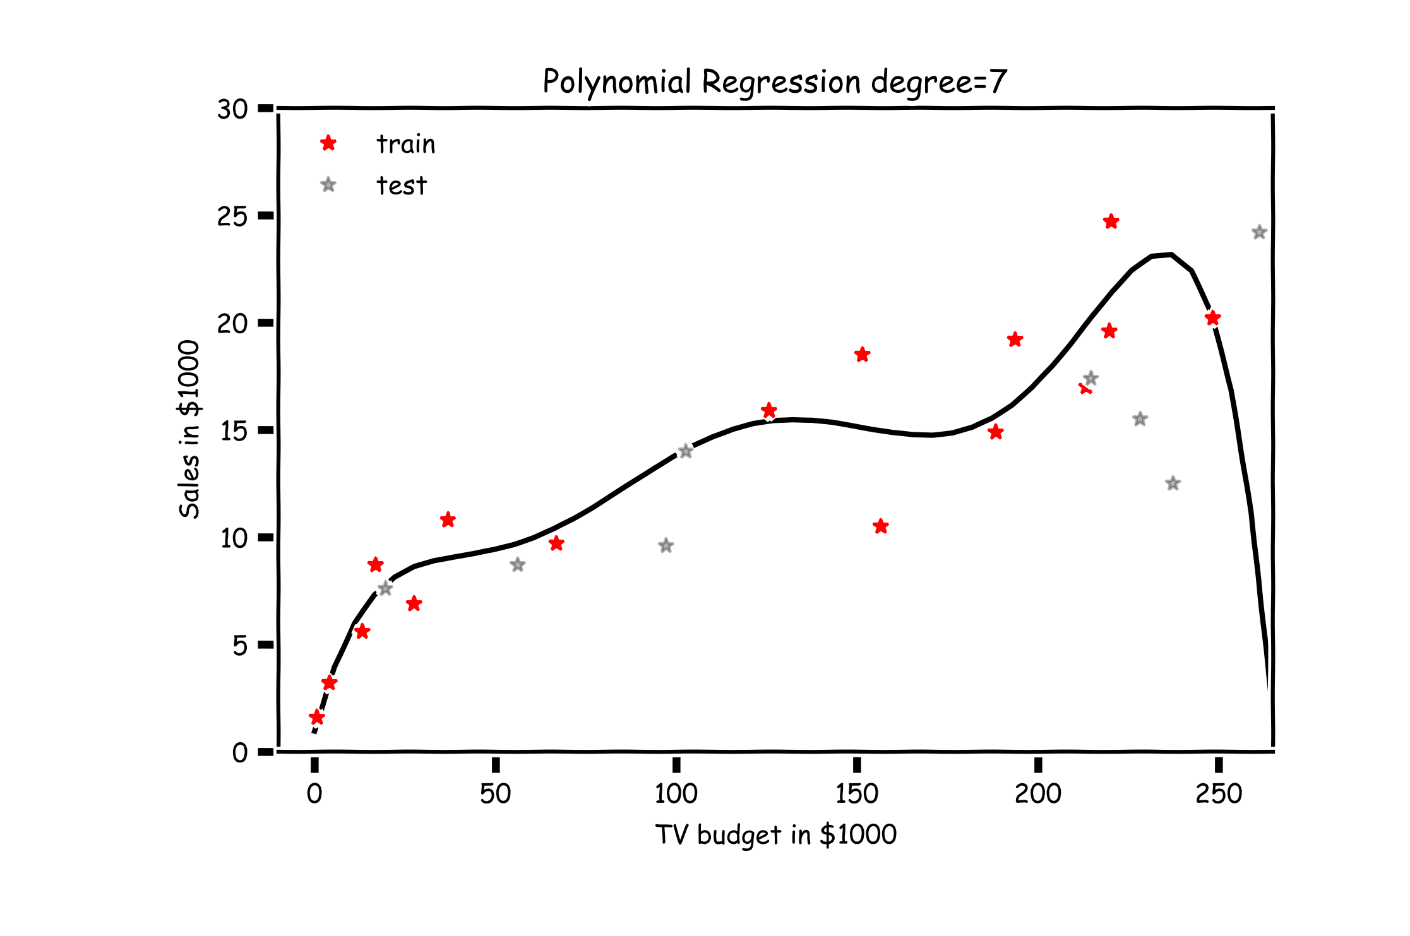

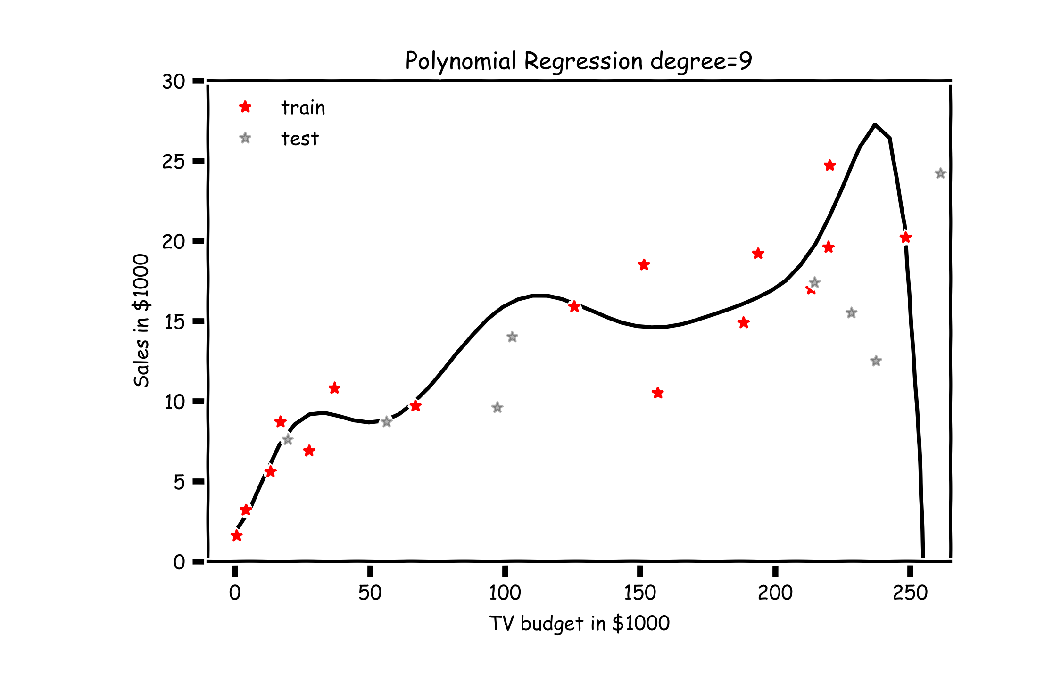

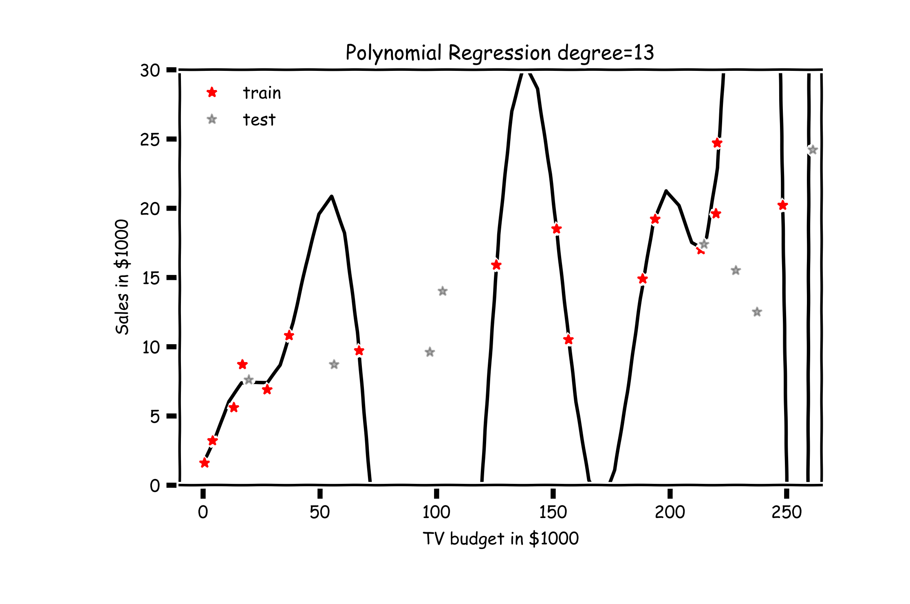

Validation

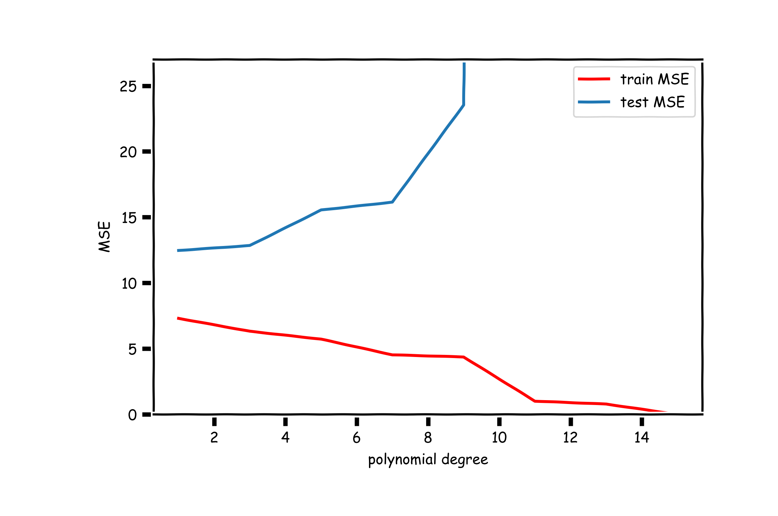

Train-Validation-Test

**Question:**

How would you report the 6543TGREPCHECK2&&**(11 performance of the model?

R2_test = 0.52 6543tgrepcheck2&&**(11

R2_train(degree=1) = 0.83

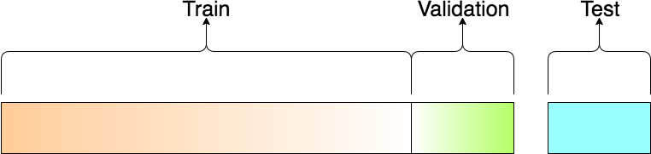

### Lecture Outline

Overfitting **Model Selection** Cross Validation Bias vs Variance

**Model selection** is the application of a principled method to determine the complexity of the model, e.g. choosing a subset of predictors, choosing the degree of the polynomial model etc.

A strong motivation for performing model selection is to avoid overfitting, which can happen when:

* there are too many predictors:
  + the feature space has high dimensionality
  + the polynomial degree is too high
  + too many cross terms are considered
* the coefficients values are too **extreme (we have not seen this yet)**

**Question:**

How many different models when considering J predictors?

**Example: 3 predictors** (𝑿𝟏, 𝑿𝟐, 𝑿𝟑)



* + Models with 0 predictor:

M0:

* + Models with 1 predictor:

M1: 𝑋1 M2: 𝑋2 M3: 𝑋3

* + Models with 2 predictors:

M4: {𝑋1, 𝑋2}

M5: {𝑋2, 𝑋3}

M6: {𝑋3, 𝑋1}

* + Models with 3 predictors:

M7: {𝑋1, 𝑋2, 𝑋3}

2𝐽 Models

Stepwise Variable Selection and Cross Validation

Selecting optimal subsets of predictors (including choosing the degree of polynomial models) through:

* stepwise variable selection - iteratively building an optimal subset of predictors by optimizing a fixed model evaluation metric each time,
* validation - selecting an optimal model by evaluating each model on validation set.

We will also address the issue of discouraging extreme values in model parameters later.

### Stepwise Variable Selection: Forward method

In **forward selection**, we find an ‘optimal’ set of predictors by iterative building up our set.

1. Start with the empty set P0, construct the null modelM0.
2. For 𝑘 = 1, … , 𝐽:
   1. Let 𝑀𝑘−1 be the model constructed from the best set of

𝑘 − 1 predictors, 𝑃𝑘−1.

* 1. Select the predictor 𝑋𝑛𝑘, not in 𝑃𝑘−1, so that the model constructed from

𝑃𝑘 = 𝑋𝑛𝑘 ∪ 𝑃𝑘−1 optimizes a fixed metric (this can be p -value, F -stat; validation MSE, 𝑅2, or AIC/BIC on training set).

* 1. Let 𝑀𝑘 denote the model constructed from the optimal 𝑃𝑘.

1. Select the model 𝑀 amongst {𝑀0, 𝑀1, … , 𝑀𝐽} that optimizes a fixed metric (this can be validation MSE, 𝑅2; or AIC/BIS on training set)

### Stepwise Variable Selection Computational Complexity

How many models did we evaluate?

* 1st step, ***J* Models**
* 2nd step, *J-1* **Models** (add 1 predictor out of *J-1* possible)
* 3rd step, *J-2* **Models** (add 1 predictor out of *J-2* possible)
* …

*O*(*J*2) ⌧ 2*J* for large *J*

### Lecture Outline

Overfitting Model Selection **Cross Validation** Bias vs Variance

### Cross Validation

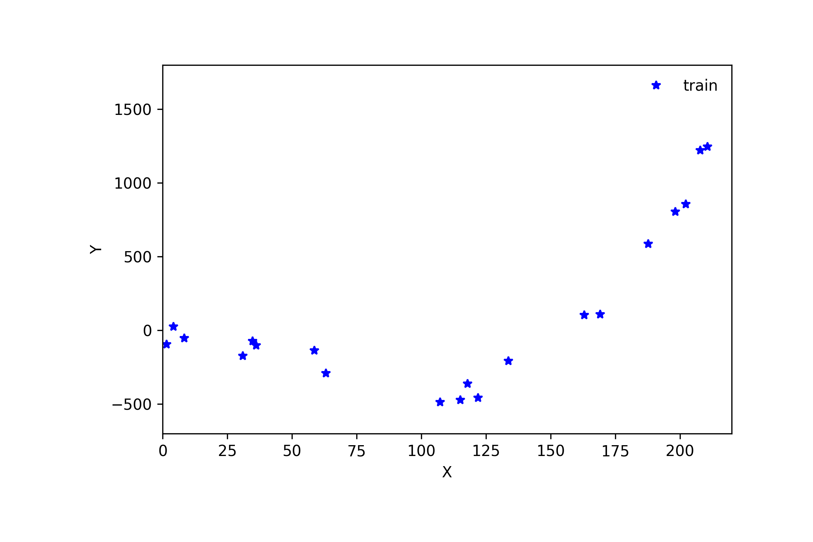

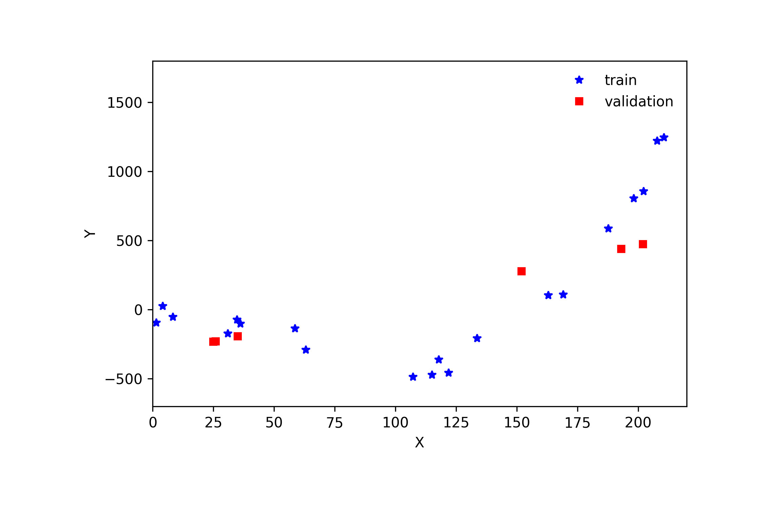

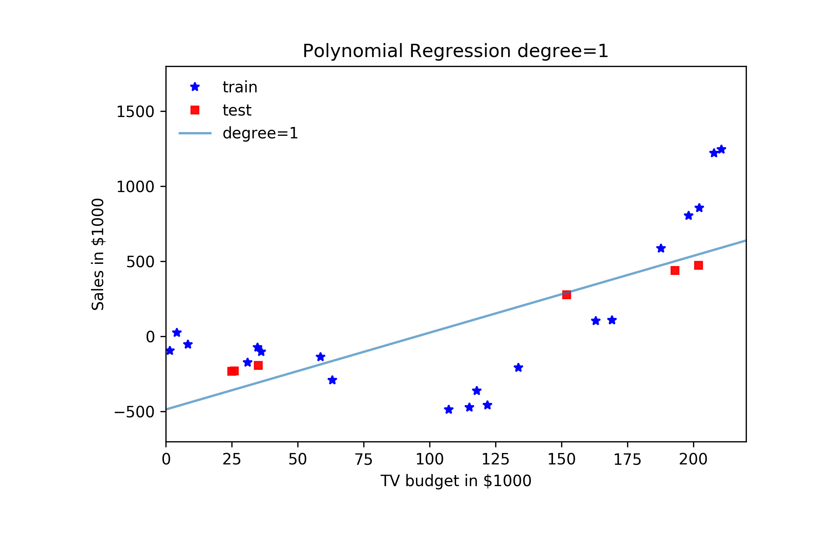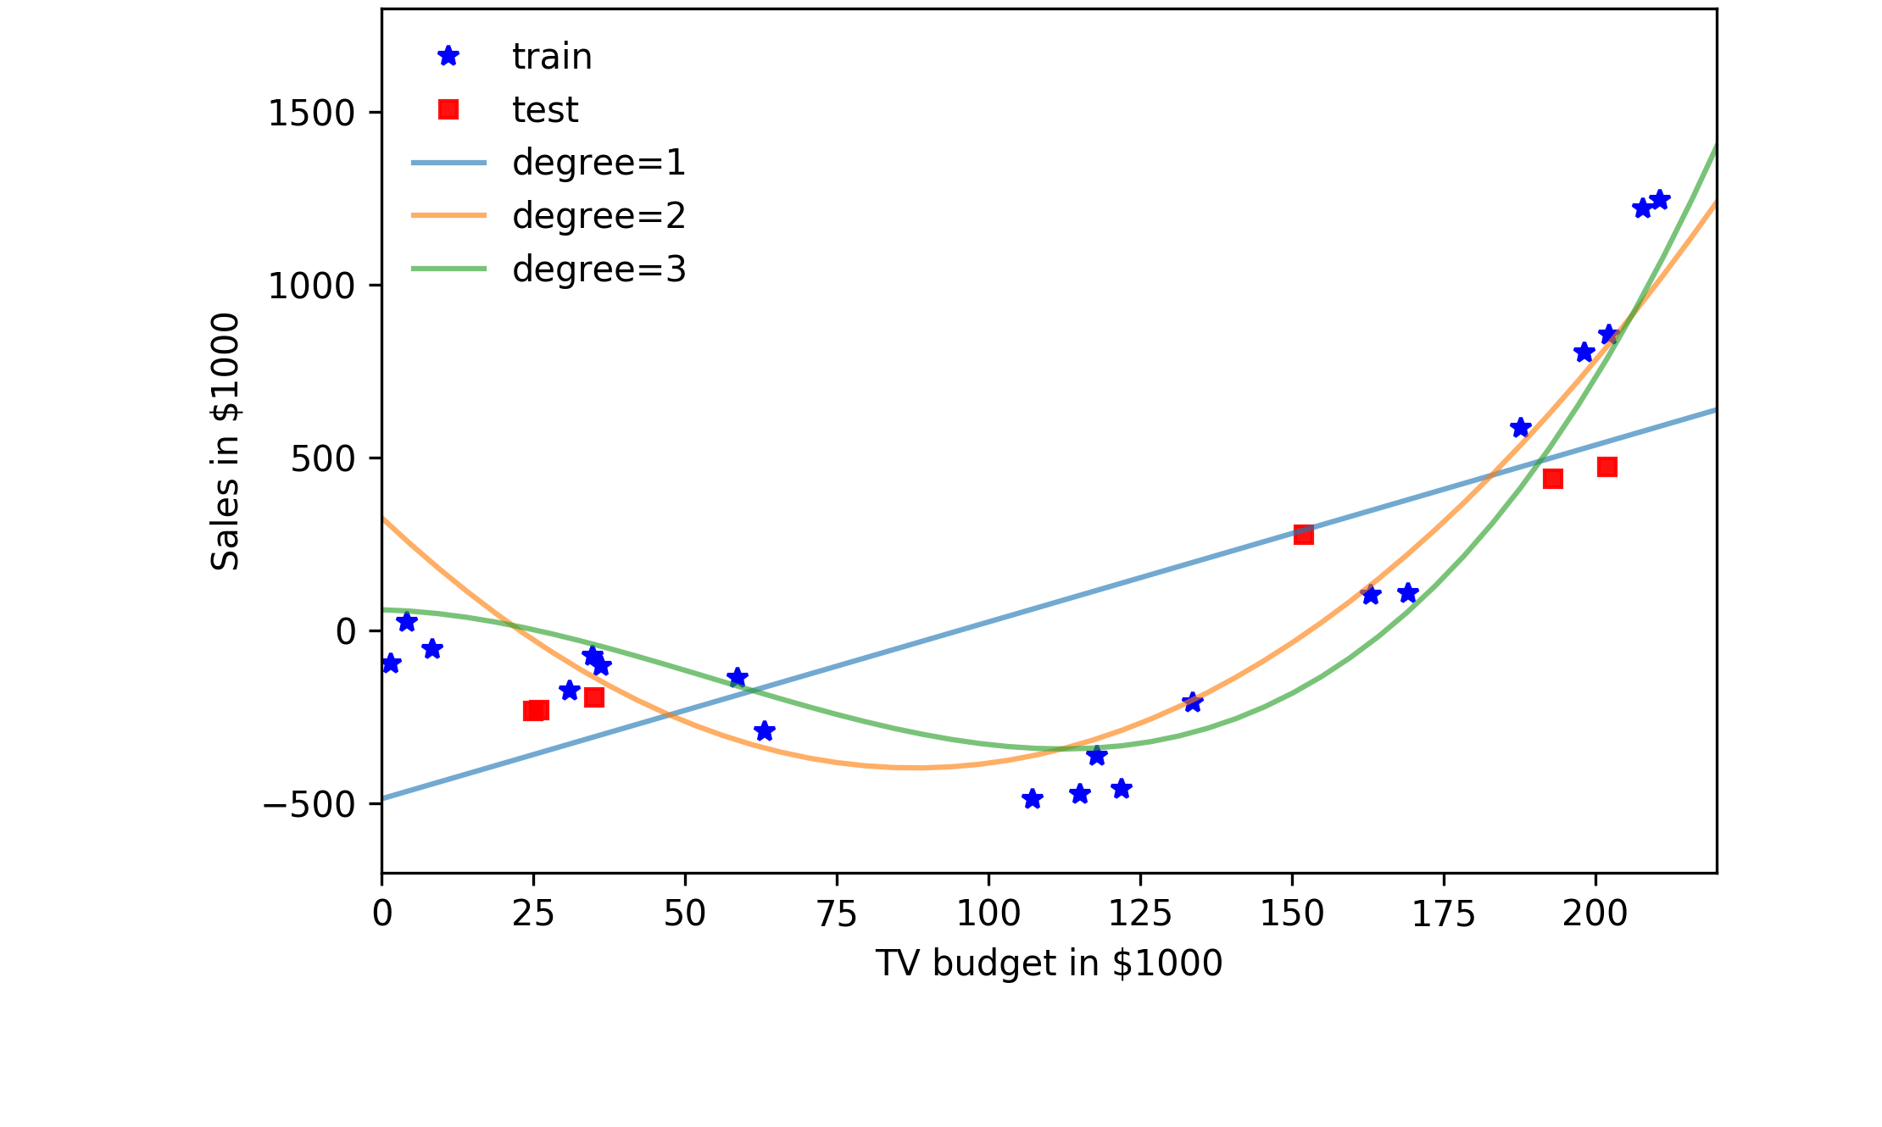

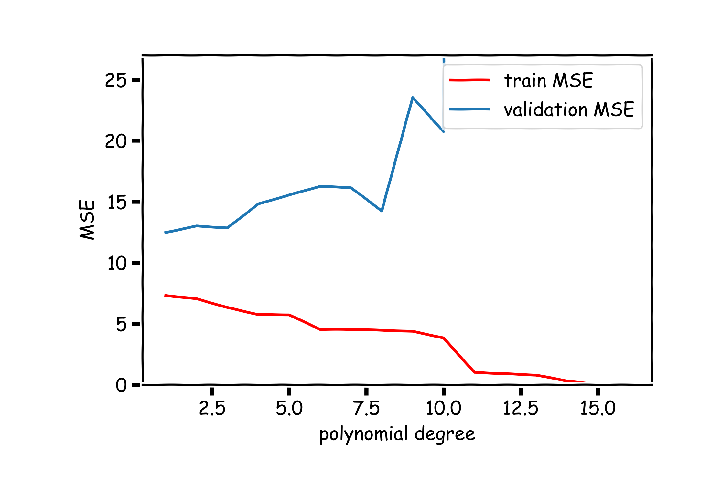

Cross Validation: Motivation

Using a single validation set to select amongst multiple models can be problematic - **there is the possibility of overfitting to the validation set**.

One solution to the problems raised by using a single validation set is to evaluate each model on **multiple** validation sets and average the validation performance.

One can randomly split the training set into training and validation multiple times **but** randomly creating these sets can create the scenario where important features of the data never appear in our random draws.

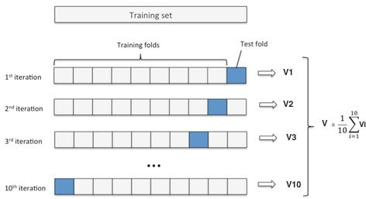

Given a data set

𝑋1, … , 𝑋𝑛

, where each

contains *J* features.

To ensure that every observation in the dataset is included in at least one training set and at least one validation set we use the **K-fold validation**:

𝑋1, … , 𝑋𝑛

* split the data into *K* uniformly sized chunks, {𝐶1, … , 𝐶𝐾}
* we create *K* number of training/validation splits, using one of the *K*

chunks for validation and the rest for training.

We fit the model on each training set, denoted 𝑓(𝐶!𝑖 , and evaluate it on the

corresponding validation set, 𝑓(𝐶!𝑖 (𝐶𝑖). The ***cross validation is the performance***

of the model averaged across all validation sets:

𝐾

1 (

Model

𝐶𝑉

where *L* is a loss function.

= 𝐾 5 𝐿(𝑓𝐶!𝑖 (𝐶𝑖))

𝑖=1

### Leave-One-Out

*Or using the* ***leave one out*** method:

* validation set: {𝑋𝑖}
* training set: 𝑋−𝑖 = {𝑋1, … , 𝑋𝑖−1, 𝑋𝑖+1, … , 𝑋𝑛}

for 𝑖 = 1, … , 𝑛:

We fit the model on each training set, denoted

𝑓(𝑋!𝑖 , and evaluate it on the

corresponding validation set, 𝑓(𝑋!𝑖 (𝑋𝑖).

The ***cross validation score*** is the performance of the model averaged across all

validation sets:

1 𝑛

𝐶𝑉

where *L* is a loss function.

= 𝑛 5 𝐿(𝑓(𝑋!𝑖 (𝑋𝑖))

𝑖=1

Model

### Predictor Selection: Cross Validation

**Question:** What is the right ratio of train/validate/test, how do I choose K?

**Question:** What is the 6543TGREPCHECK2&&**(11 difference in multiple predictors and polynomial regression in model selection?

We can frame the problem of degree selection for polynomial models as a predictor selection problem:

which of the predictors {𝑥, 𝑥2, … , 𝑥𝑚}, should we select for modeling?

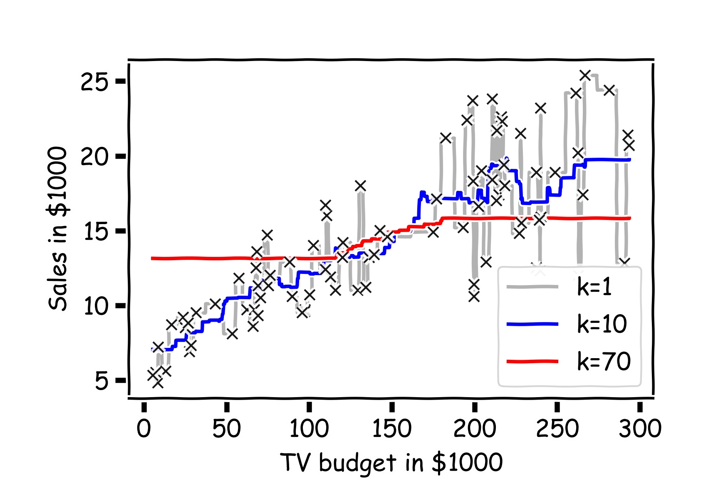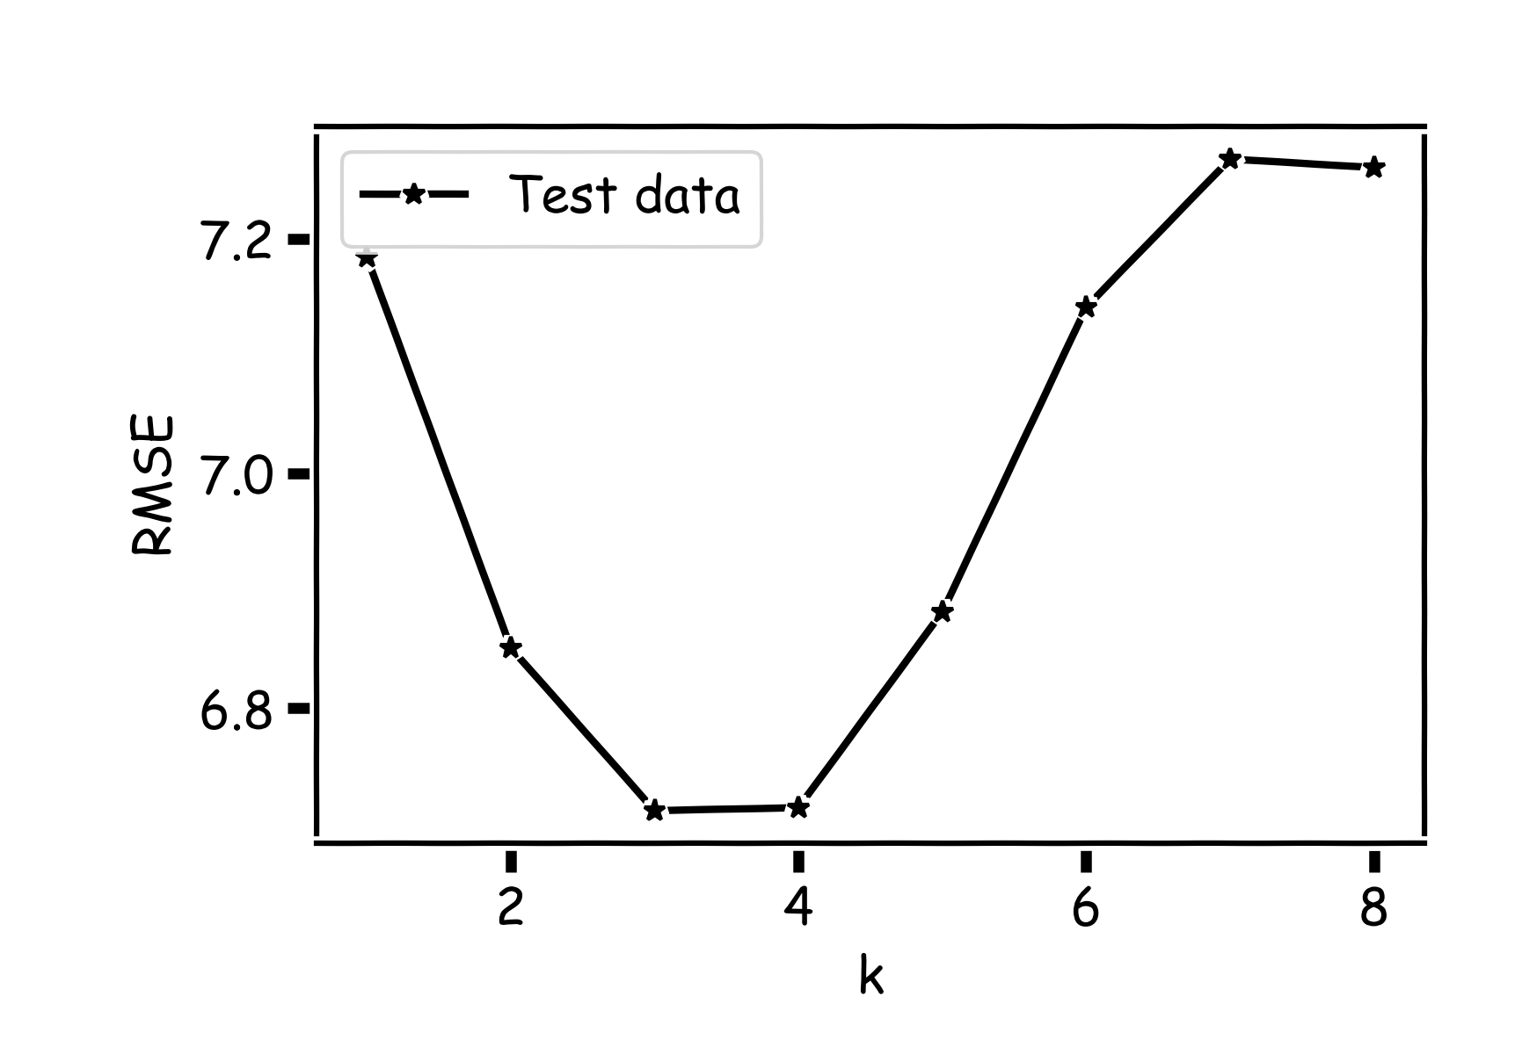

Recall our first simple, intuitive,

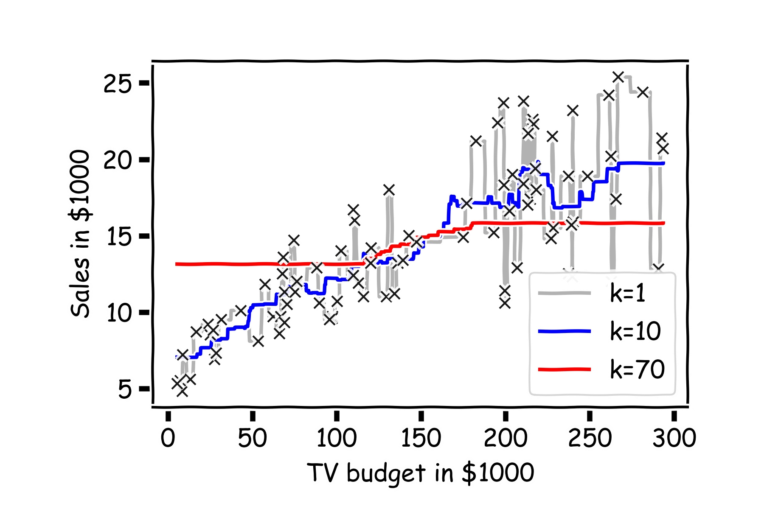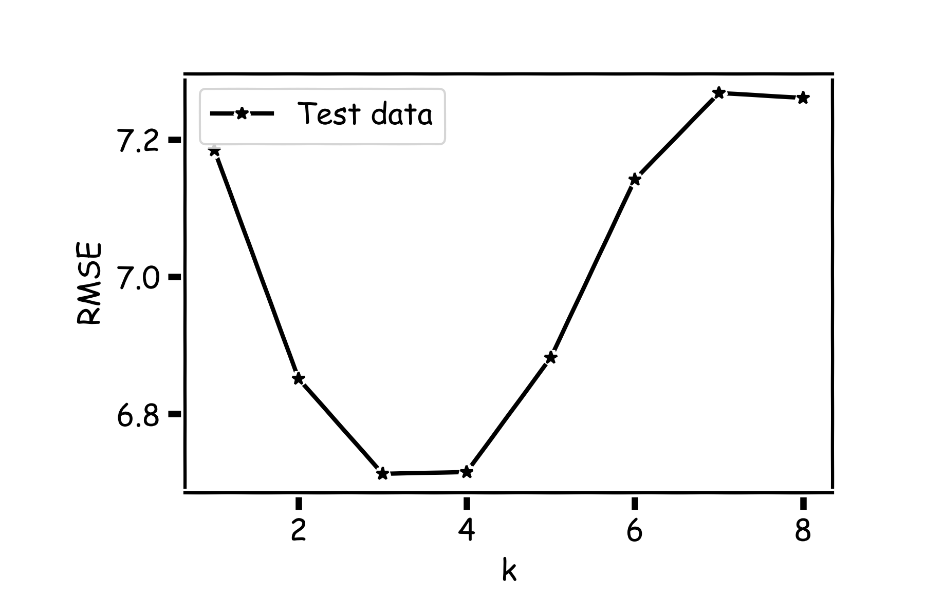

non-parametric model for regression – the kNN model. We saw that it is vitally important to select an appropriate *k* for the data.

If the *k* is too small then the model is very sensitive to noise (since a new prediction is based on very few observed neighbors), and if the *k* is too large, the model tends towards making constant predictions.

A principled way to choose *k* is **through K-fold cross validation.**

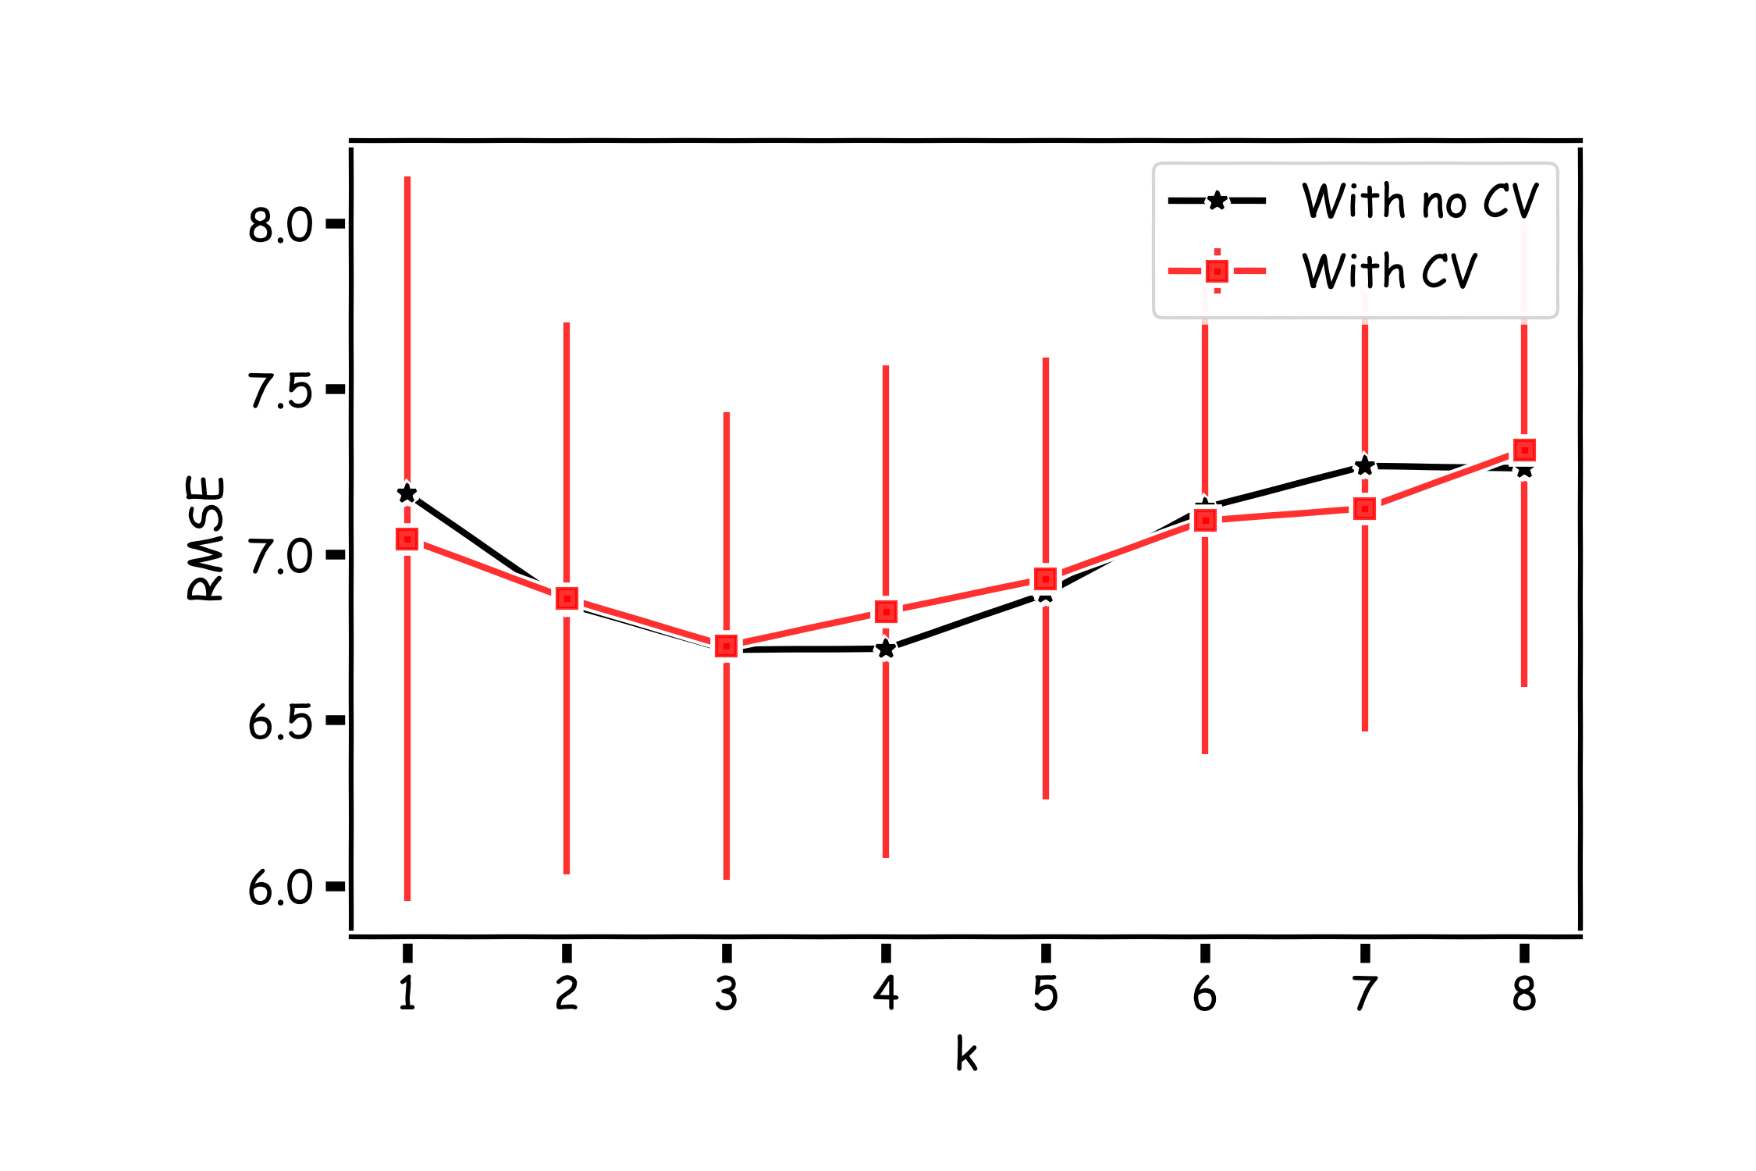

Overfitting Model Selection Cross Validation **Bias vs Variance**

### Bias vs Variance

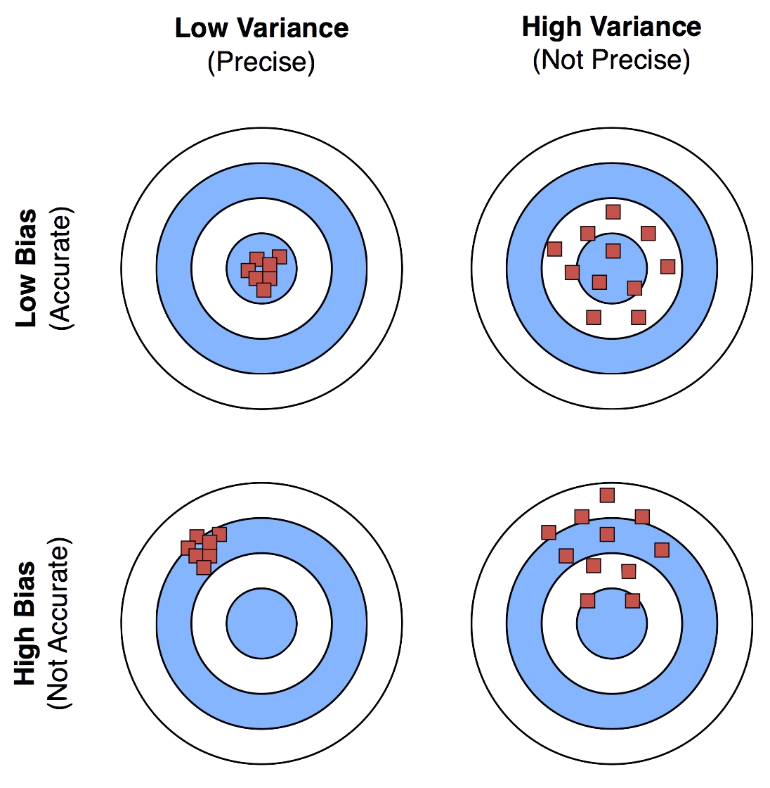

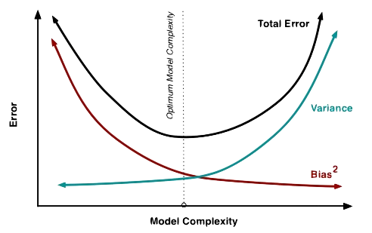

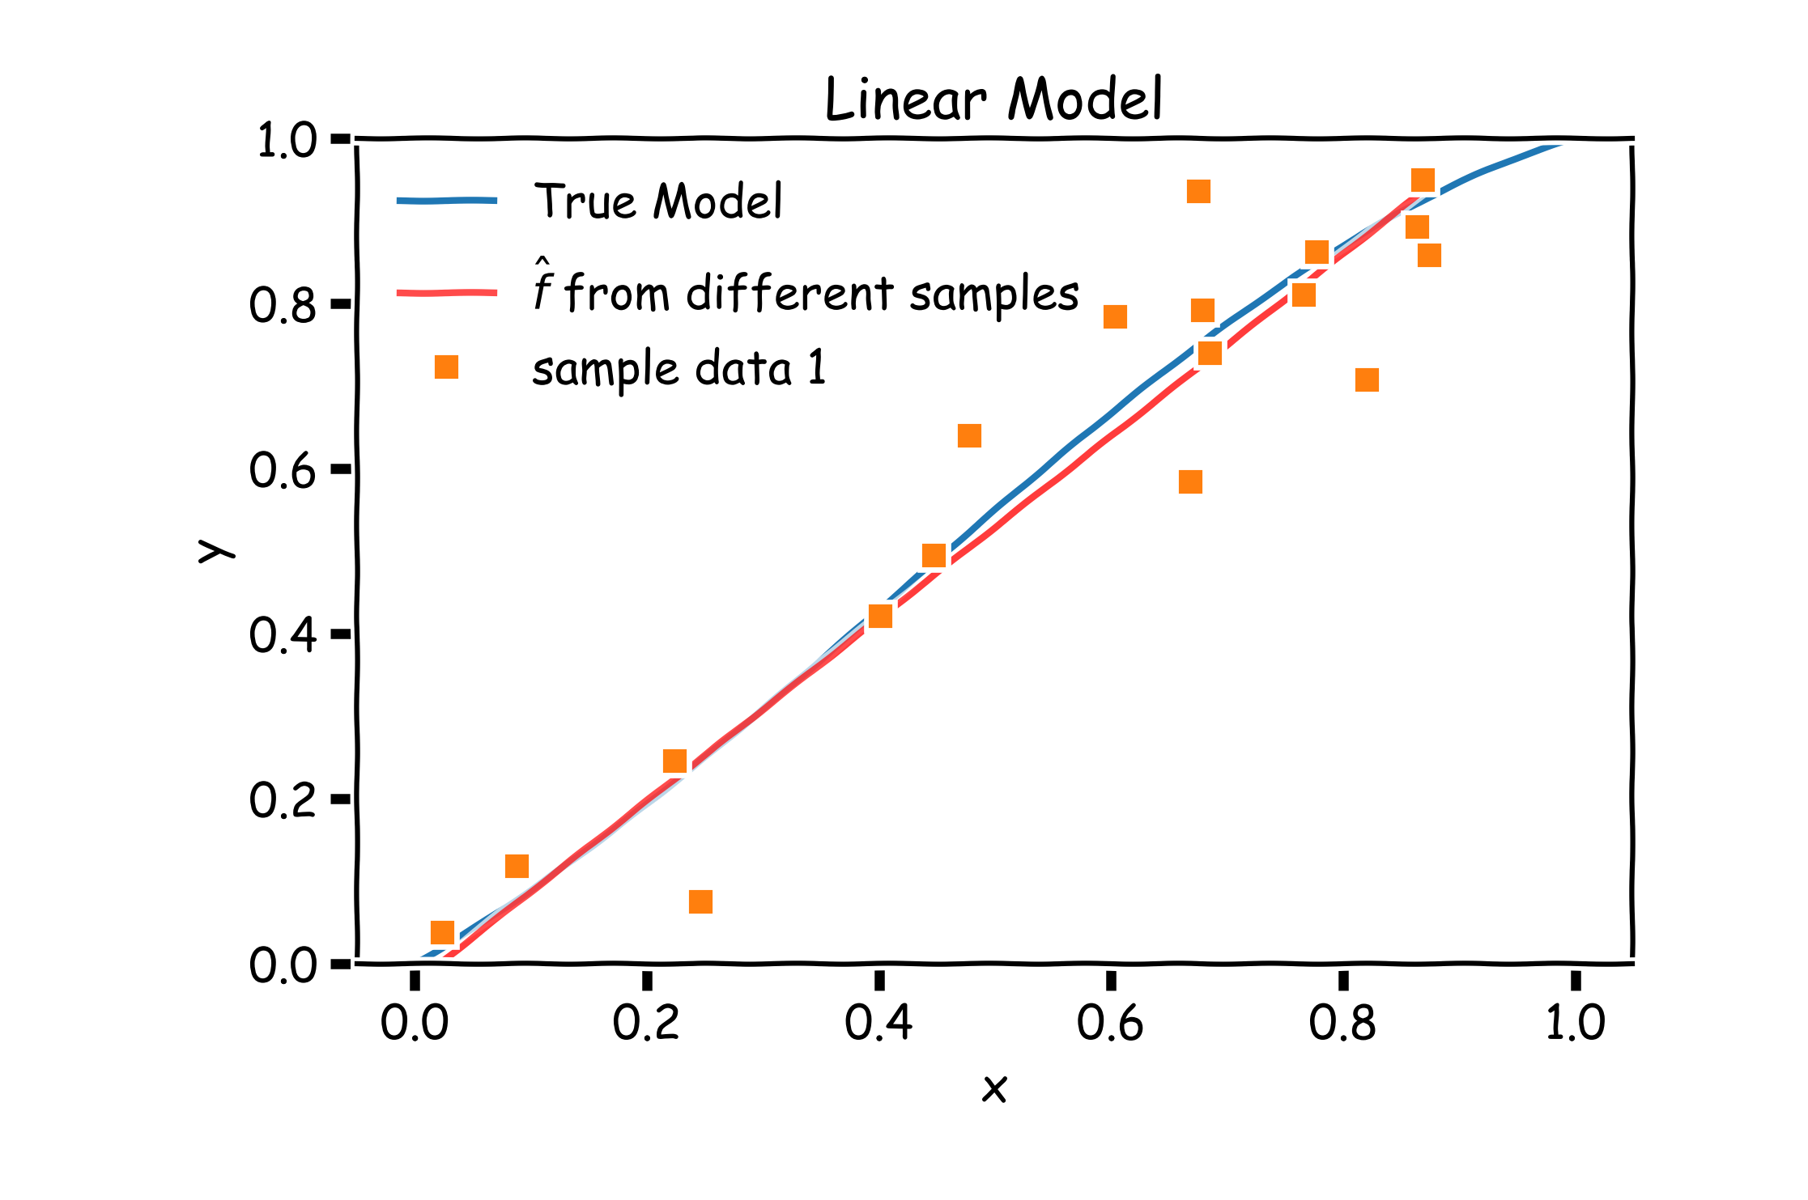

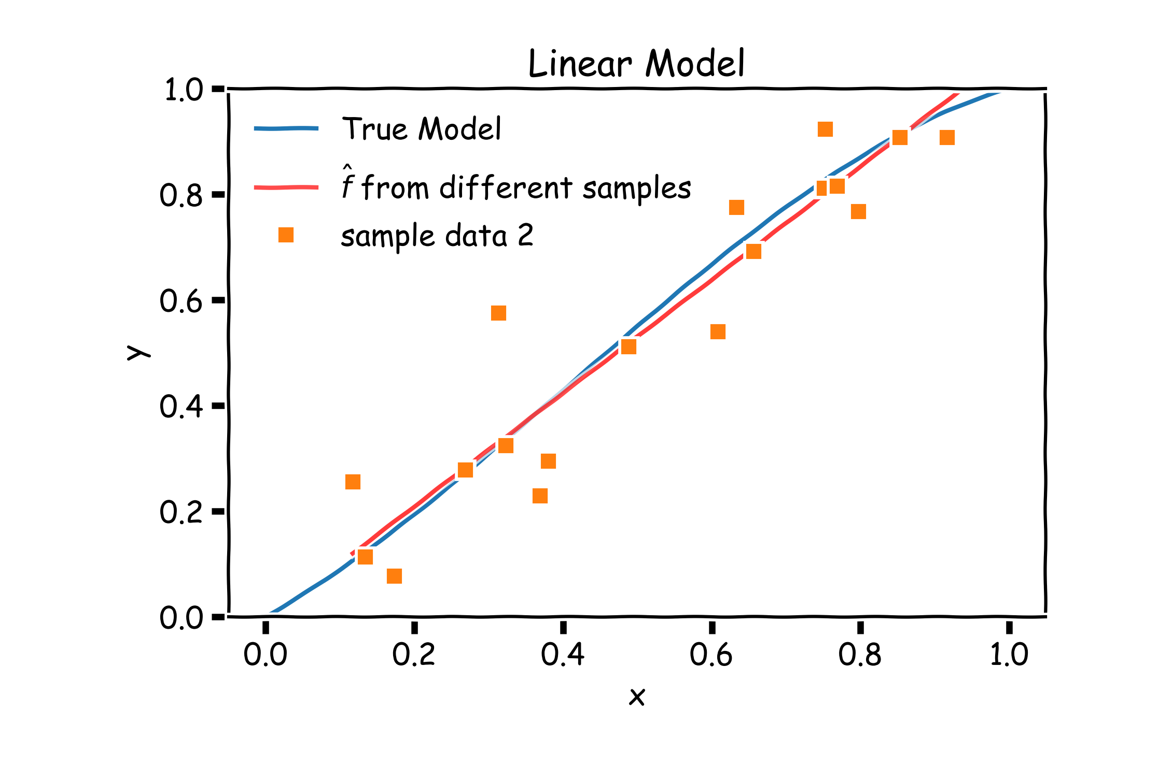

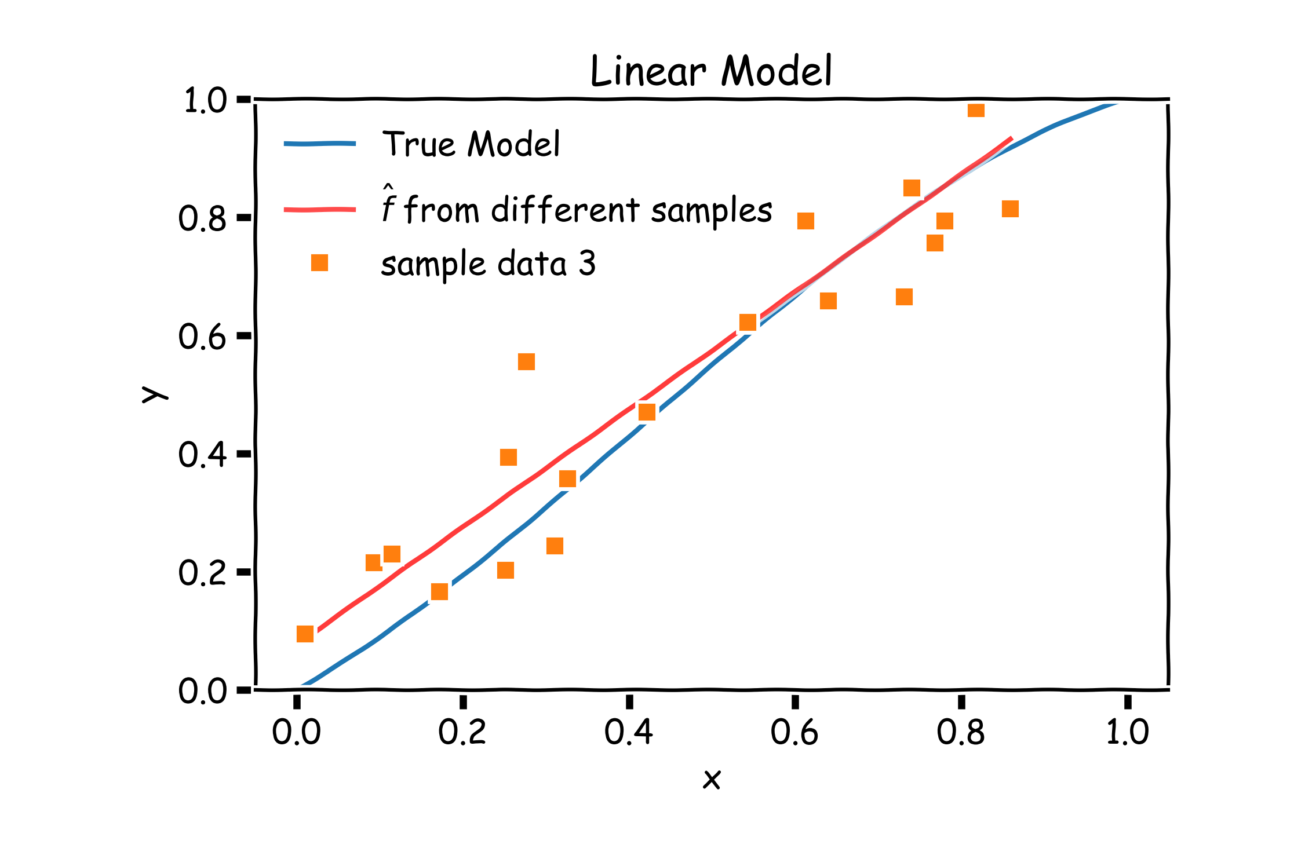

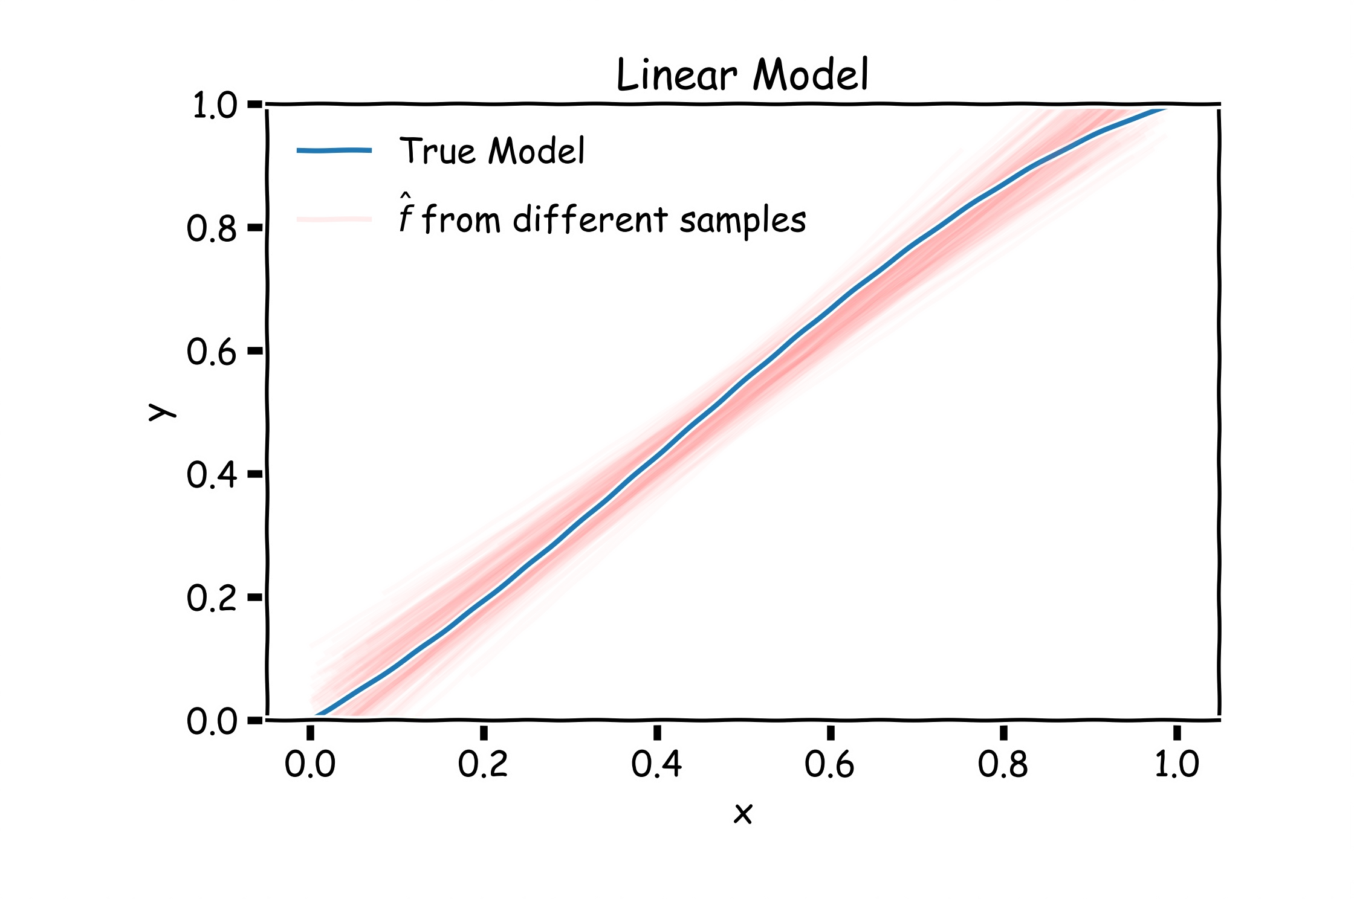

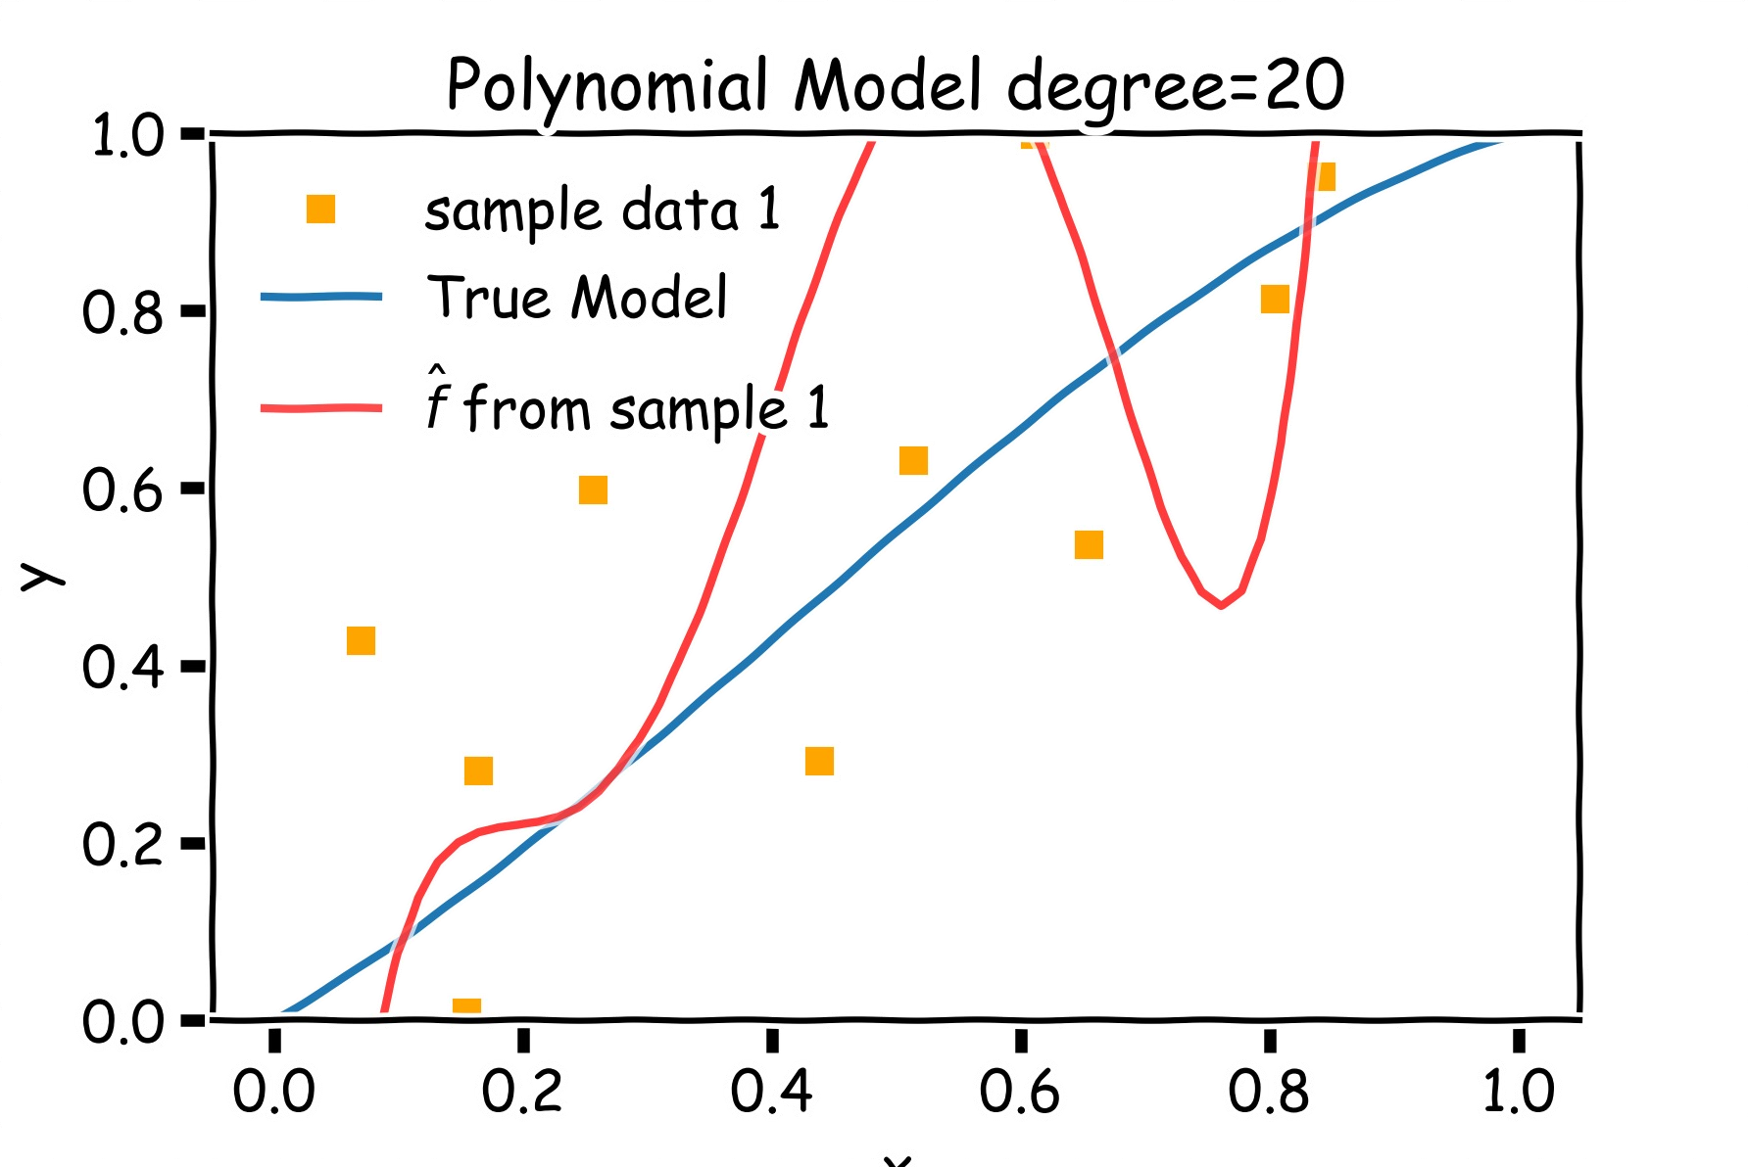

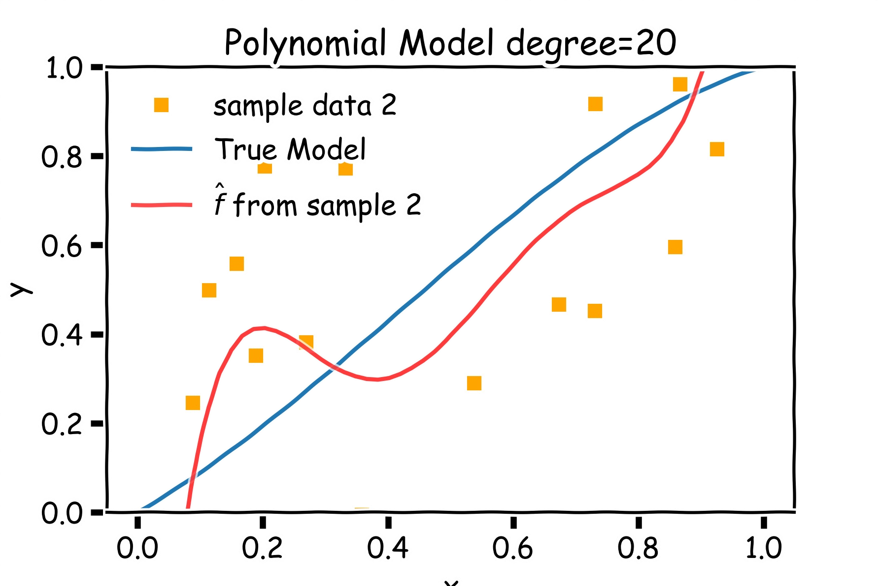

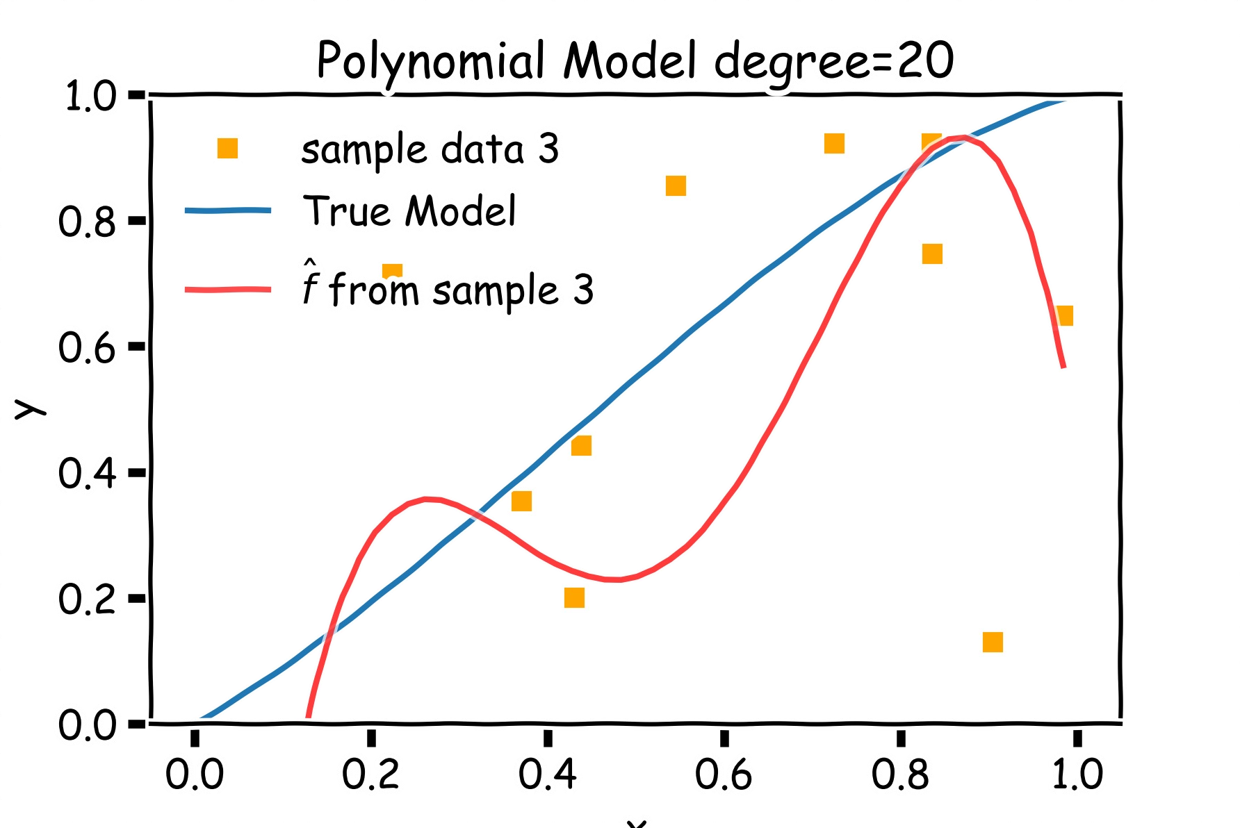

Poly 10 degree models : 20 data points per line 2000 simulations

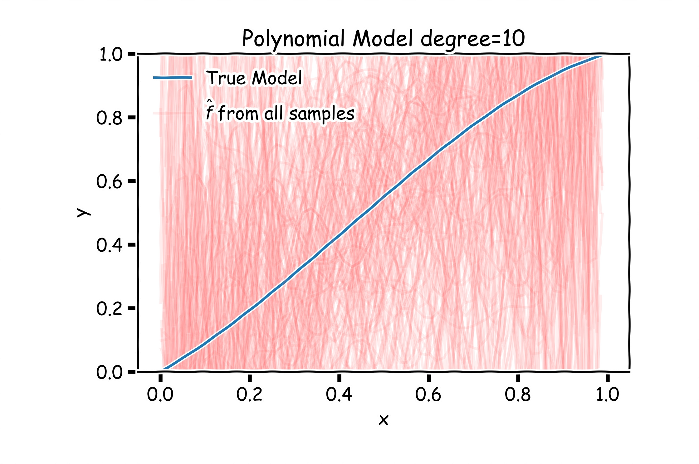

**Left**: 2000 best fit straight lines, each fitted on a different 20 point training set.

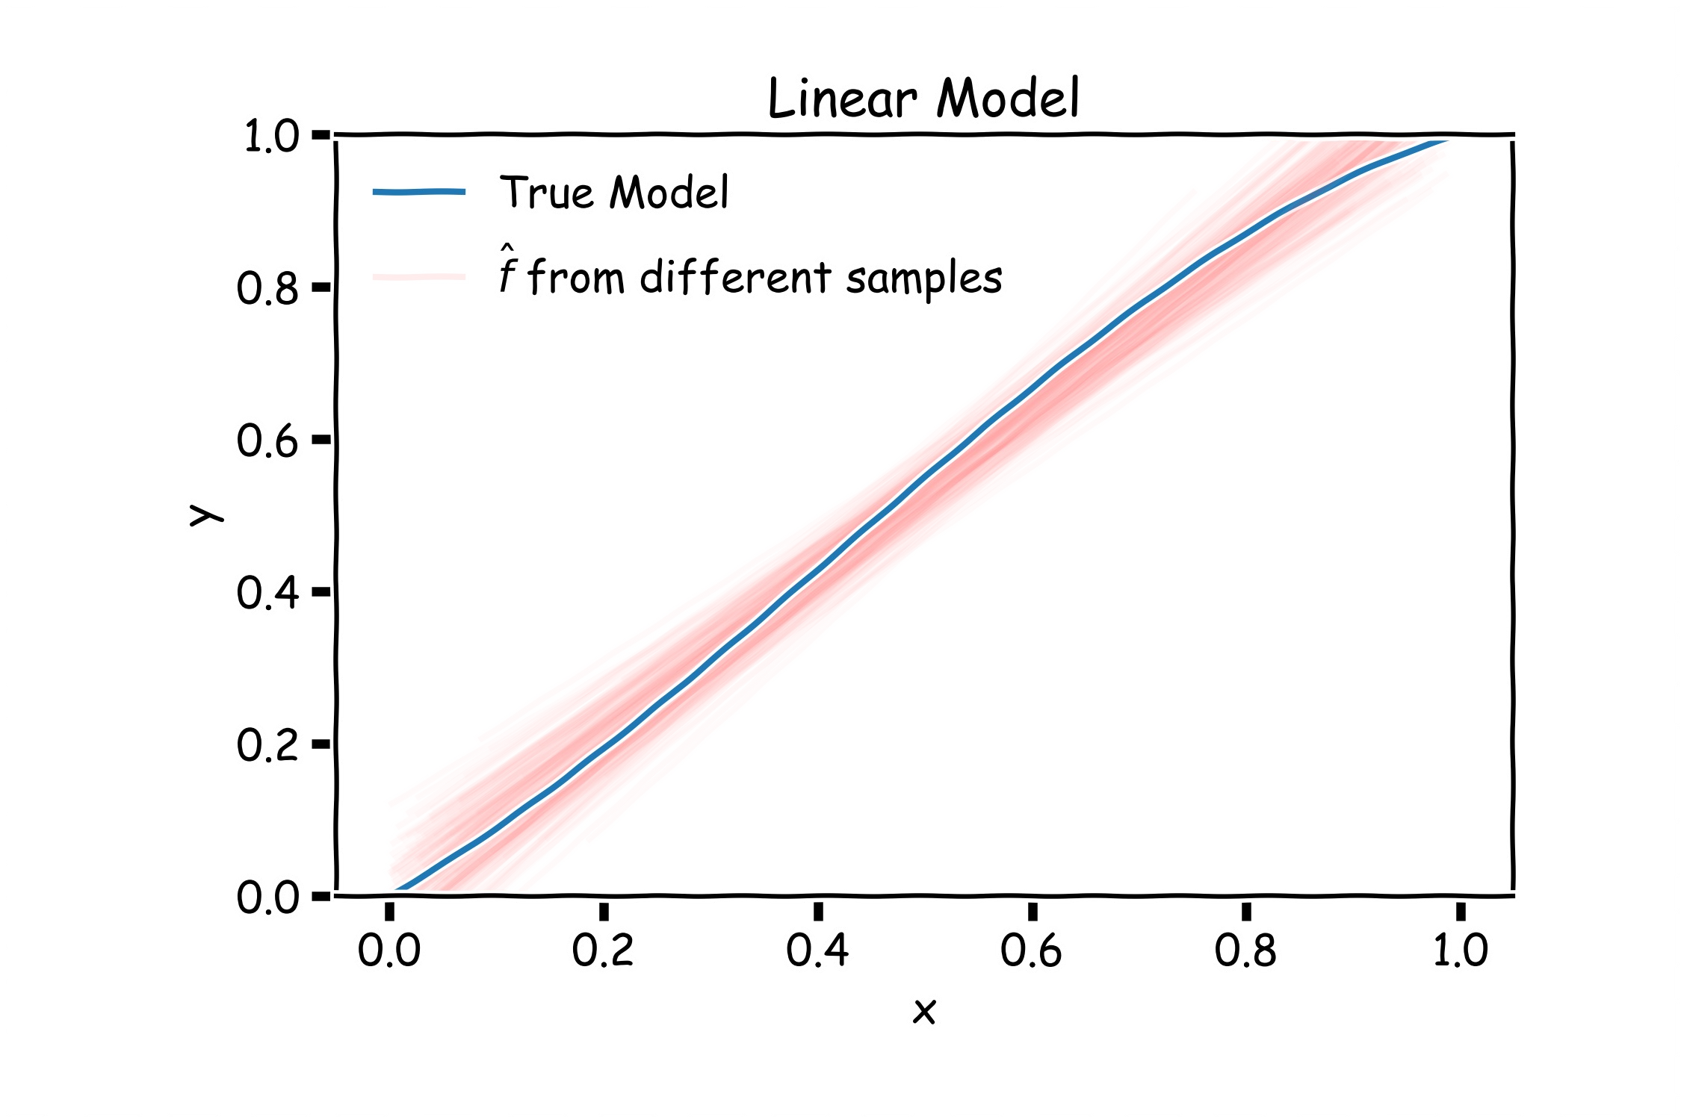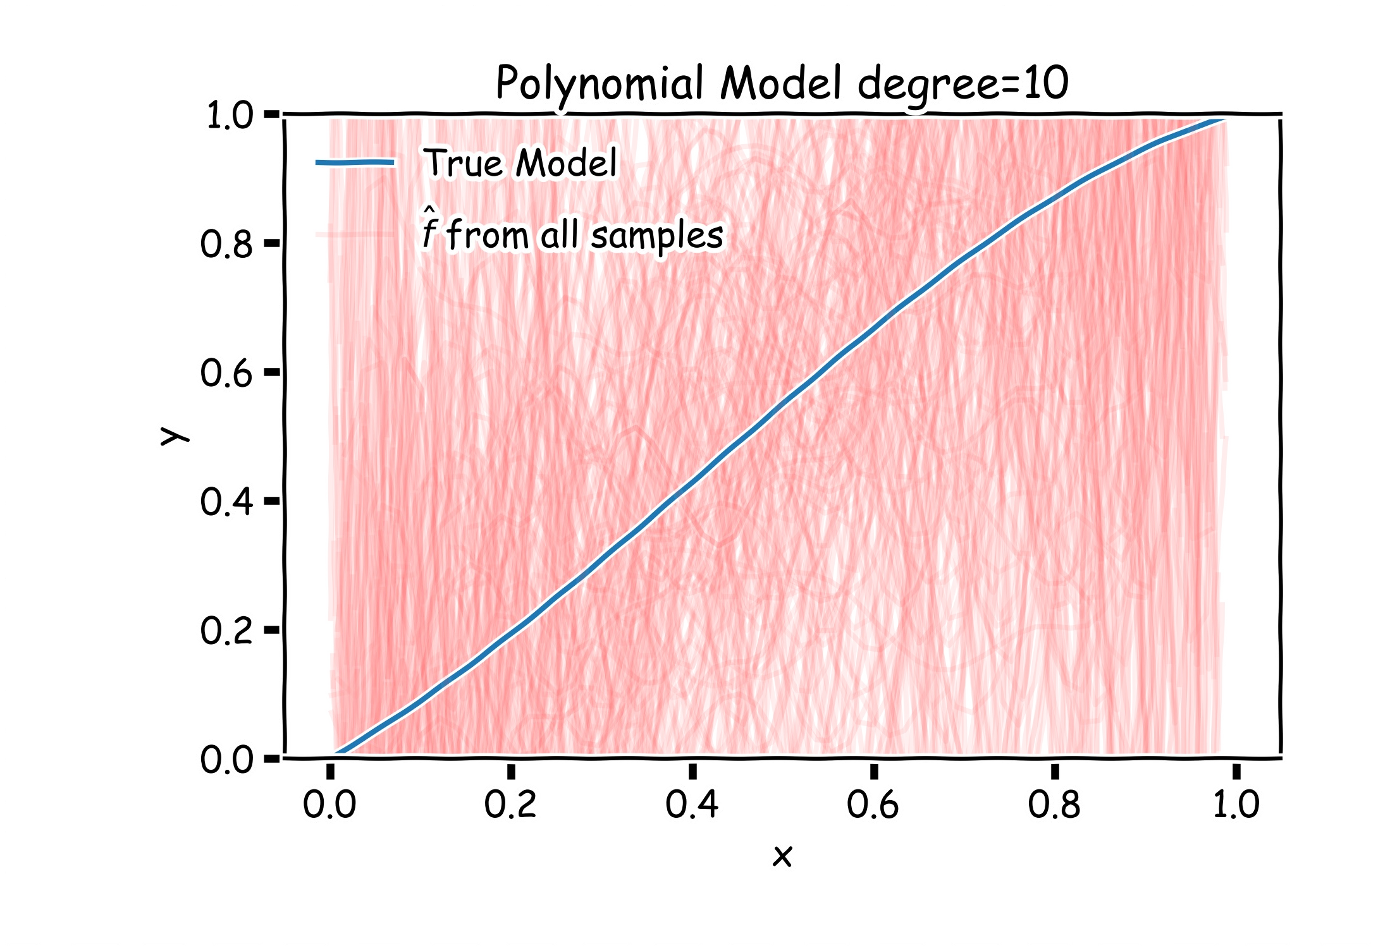

**Right**: Best-fit 6543tgrepcheck2&&**(11 models using degree 10 polynomial

67

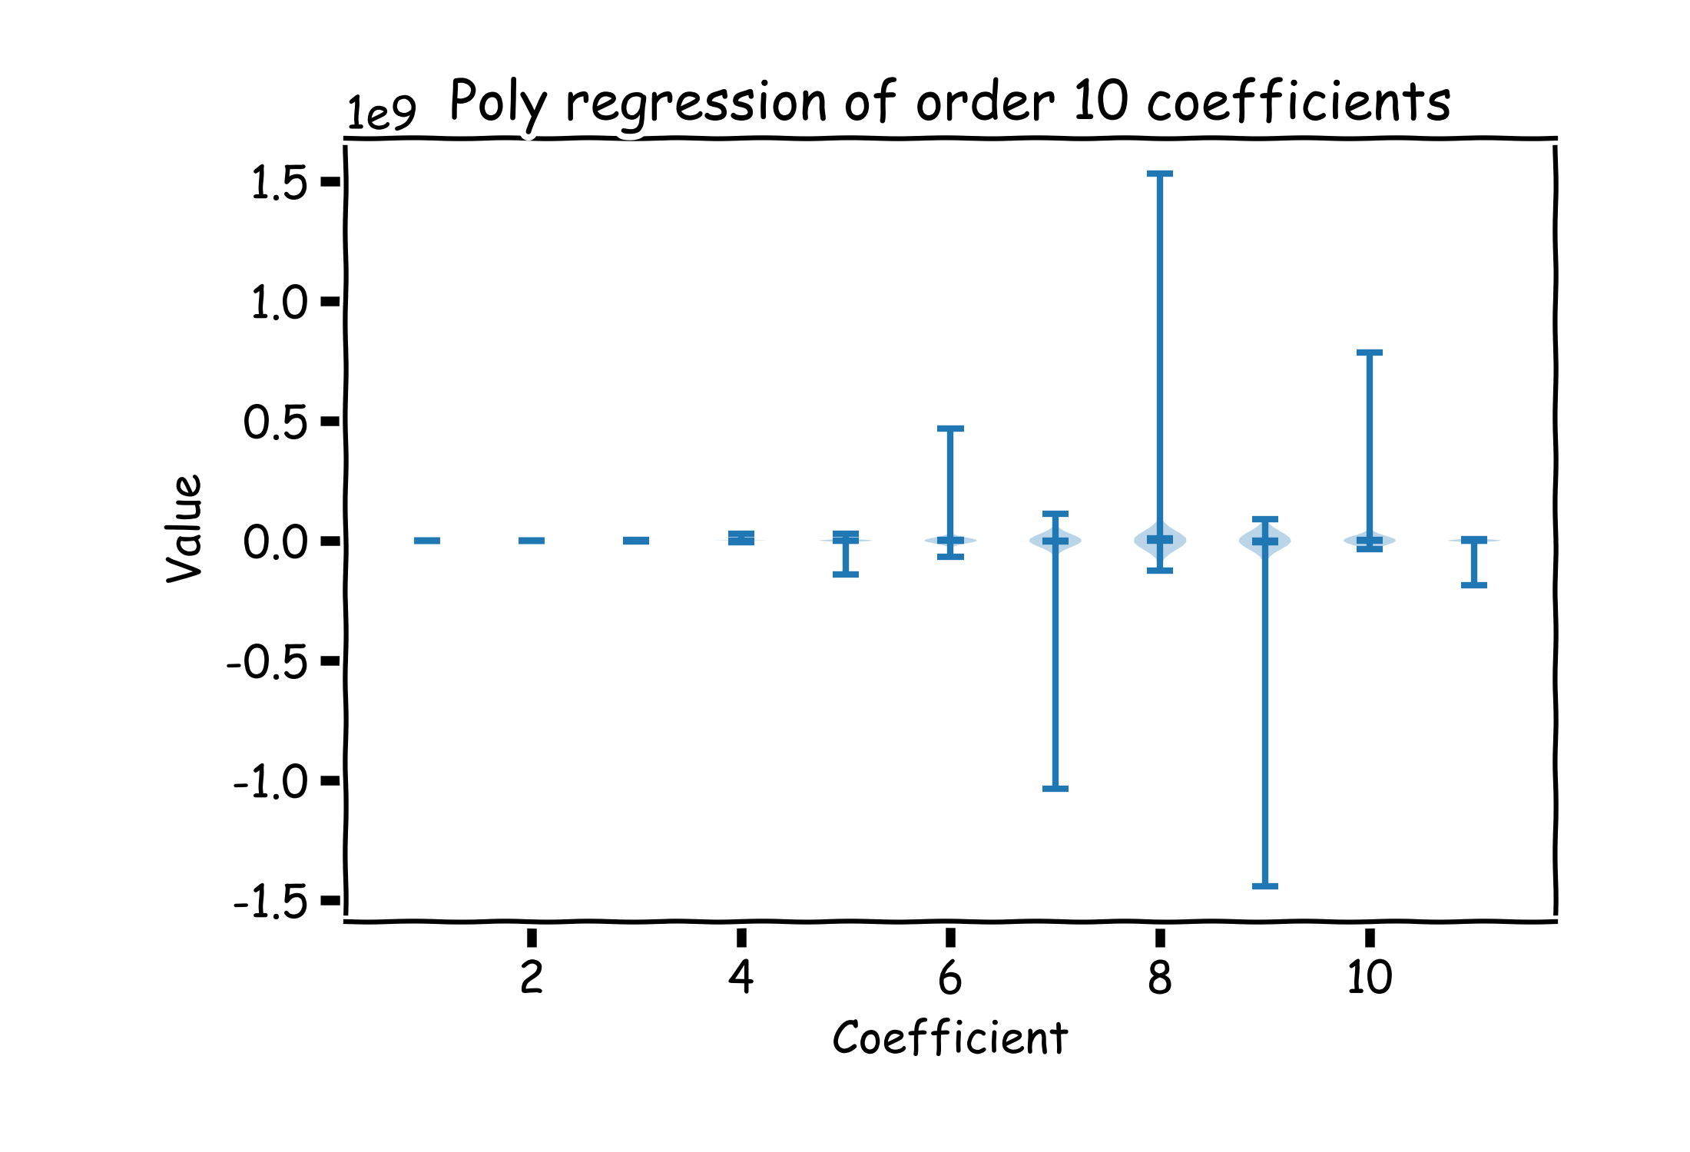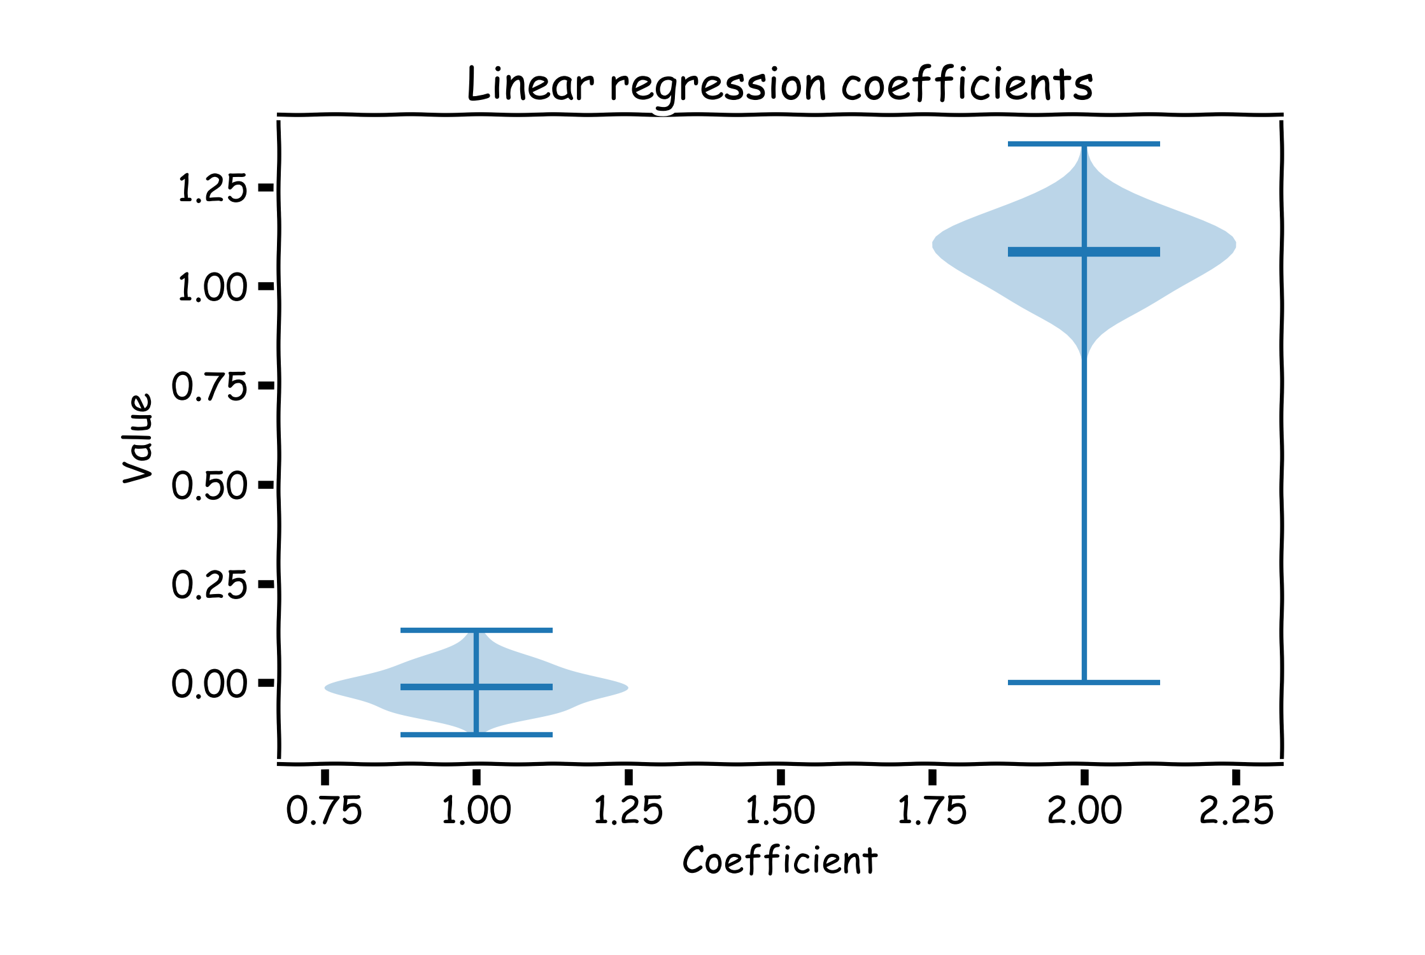

Left: Linear regression coefficients

Right: Poly regression of order 10 coefficients

𝛽0 𝛽1

### Lecture Outline

Overfitting Model Selection Cross Validation Bias vs Variance